Department of Veterans Affairs

Veterans Health Administration (VHA)

Office of Informatics and Analytics

Innovation Program

OneVA Pharmacy Implementation Project

System Design Document (SSD)

(CLIN #0002AC)

Business Information Technology Solutions, Inc.

3190 Fairview Park Drive, Suite 315

Falls Church, VA 22042

Task Order: VA-118-15-Q-0745



Version 1.1

January 2016

Revision History

Note: The revision history cycle begins once changes or enhancements are requested after the Requirements Specification Document has been baselined.

| Date | Version | Description | Author |
| --- | --- | --- | --- |
| 10/26/2015 | 0.1 | Initial Draft | Kathy Coupland |
| 10/29/2015 | 0.2 | Updated Sections 2, 3, 4, 5, and 8 | Tony Burleson |
| 11/13/2015 | 0.3 | Updated Diagrams, spelled out acronyms, and applied TJ Cope’s comments. Added Brad Fisher’s updates. | Kathy Coupland |
| 11/28/2015 | 0.4 | Updated diagram and modified two requirements. | Kathy Coupland |
| 12/28/2015 | 0.5 | Updated section 6.2 and eMI areas | Tony Burleson |
| 12/30/2015 | 1.0 | Baseline | Kathy Coupland |
| 01/04/2016 | 1.1 | Update Section 6.5 & namespace update. | Kathy Coupland |

Table of Contents

1. Introduction 9

1.1. Scope 9

1.2. User Profiles 9

1.3. Acronyms and Abbreviations 9

2. Background 11

2.1. Overview of the System 11

2.2. Overview of the Business Process 12

2.3. Overview of the Significant Requirements 12

2.3.1. Business Rules 12

2.3.2. Design Constraints 13

2.3.3. Documentation Specifications 13

2.3.4. Functional Requirements 13

3. Conceptual Design 14

3.1. Conceptual Application Design 14

3.1.1. Application Context 14

3.1.2. High-Level Application Design 15

3.2. Use Case Name: View Orders 16

3.3. Use Case Name: Dispense Local Order 16

3.4. Use Case Name: Dispense Remote Order 17

3.4.1. Application Locations 18

3.5. Conceptual Data Design 18

3.5.1. Project Conceptual Data Model 18

3.5.2. Database Information 18

3.5.3. User Interface Data Mapping 19

3.5.3.1. Application Screen Interface 19

3.5.3.2. Application Report Interface 19

3.5.3.2.1. Prescriptions we have filled for other facilities 19

3.5.3.2.2. Our prescriptions, filled by other facilities 20

3.5.3.2.3. All Remote activity 21

3.5.3.3. Unmapped Data Element 23

3.6. Conceptual Infrastructure Design 23

3.6.1. System Criticality and High Availability 23

3.6.2. Special Technology 23

3.6.3. Technology Locations 24

3.6.4. Conceptual Infrastructure Diagram 25

3.6.4.1. Location of Environments and External Interfaces 25

3.6.4.2. Conceptual Production String Diagram 25

4. System Architecture 25

4.1. Hardware Architecture 25

4.2. Software Architecture 26

4.2.1. eMI ESB 26

4.2.2. HDR/CDS Endpoint 26

4.2.3. Sequence Diagrams 26

4.2.3.1. View Order 26

4.2.3.2. Dispense Remote Order Sequence Diagram 27

4.2.4. Design Rationale 28

4.2.5. HL7 Protocol 29

4.3. Network Architecture 29

4.4. Service Oriented Architecture / ESS 29

4.5. Enterprise Architecture 30

5. Data Design 31

5.1. DBMS Files 31

5.1.1. Refill Multiple (#52.1) of the Prescription File (#52) 31

5.1.2. Partial Multiple (#52.2) of the Prescription File (#52) 31

5.1.3. Remote Prescription Log (#52.09) 31

5.2. Non-DBMS Files 33

5.3. Data View 33

6. Detailed Design 33

6.1. Hardware Detailed Design 33

6.2. Software Detailed Design 33

6.2.1. Conceptual Design 33

6.2.1.1. Product Perspective 33

6.2.1.1.1. User Interfaces 34

6.2.1.1.2. Hardware Interfaces 34

6.2.1.1.3. Software Interfaces 34

6.2.1.1.4. Communications Interfaces 34

6.2.1.1.5. Memory Constraints 34

6.2.1.1.6. Special Operations 35

6.2.1.2. Product Features 35

6.2.1.3. User Characteristics 35

6.2.1.4. Dependencies and Constraints 35

6.2.2. Specific Requirements 35

6.2.2.1. Database Repository 35

6.2.2.2. System Features 35

6.2.2.3. Design Element Tables 35

6.2.2.3.1. Routines (Entry Points) 35

6.2.2.3.1.1. PSOORNE2 35

6.2.2.3.1.2. PSOORUT1 37

6.2.2.3.1.3. PSOROS 38

6.2.2.3.1.4. PSORRD 39

6.2.2.3.1.5. PSORREF 40

6.2.2.3.1.6. PSORREF0 41

6.2.2.3.1.7. PSORREF1 42

6.2.2.3.1.8. PSORRP 43

6.2.2.3.1.9. PSORRPA1 44

6.2.2.3.1.10. PSORRX1 45

6.2.2.3.1.11. PSORWRAP 46

6.2.2.3.1.12. PSORX1 47

6.2.2.3.2. Templates 49

6.2.2.3.2.1. PSO LM REMOTE ORDER SELECTION 49

6.2.2.3.3. Bulletins 50

6.2.2.3.4. Data Entries Affected by the Design 50

6.2.2.3.5. Unique Record(s) 51

6.2.2.3.6. File or Global Size Changes 51

6.2.2.3.6.1. Global 51

6.2.2.3.6.2. Files 51

6.2.2.3.7. Mail Groups 54

6.2.2.3.8. Security Keys 54

6.2.2.3.9. Options 54

6.2.2.3.9.1. Pharmacy Remote Prescription Manager Options 54

6.2.2.3.10. Protocols 57

6.2.2.3.11. Remote Procedure Call (RPC) 63

6.2.2.3.12. Constants Defined in Interface 63

6.2.2.3.13. Variables Defined in Interface 63

6.2.2.3.14. Types Defined in Interface 63

6.2.2.3.15. GUI 63

6.2.2.3.16. GUI Classes 63

6.2.2.3.17. Current Form 64

6.2.2.3.18. Modified Form 64

6.2.2.3.19. Components on Form 64

6.2.2.3.20. Events 64

6.2.2.3.21. Methods 64

6.2.2.3.22. Special References 64

6.2.2.3.23. Class Events 64

6.2.2.3.24. Class Methods 64

6.2.2.3.25. Class Properties 65

6.2.2.3.26. Uses Clause 65

6.2.2.3.27. Forms 66

6.2.2.3.28. Functions 66

6.2.2.3.29. Dialog 66

6.2.2.3.30. Help Frame 66

6.2.2.3.31. HL7 Application Parameter 66

6.2.3. HL7 Protocols 66

6.2.4. HL7 Sender and Receiver Applications 68

6.2.5. Sender and Receiver Logical Links 69

6.2.5.1.1. HL7 Logical Link 71

6.2.5.1.2. COTS Interface 72

6.3. Network Detailed Design 72

6.4. Security and Privacy 72

6.4.1. Security 72

6.4.1.1. Secure Sockets Layer (SSL) 72

6.4.1.2. Authentication and Authorization 72

6.4.1.3. Remote Prescription Locking 72

6.4.2. Privacy 72

6.5. Service Oriented Architecture / ESS Detailed Design 73

6.5.1. Service Description for <Consumed Service Name> 73

6.5.2. Service Design for <Provided Service Name> 73

7. External System Interface Design 73

7.1. Interface Architecture 73

7.2. Interface Detailed Design 73

7.3. Acknowledgement Codes 73

7.4. Order Control Codes 73

7.5. Remote Prescription Query Transaction 74

7.5.1. Remote Prescription Query Request 74

7.5.2. Sample QBP^Q13 Request 75

7.5.3. Remote Prescription Query Response 75

7.5.4. Sample KTB^K13 Response 76

7.6. Remote Prescription Dispense Transaction 77

7.6.1. Remote Description Dispense Request 77

7.6.2. Remote Description Dispense Response 79

8. Human-Machine Interface 81

8.1. Interface Design Rules 81

8.2. Inputs 81

8.3. Outputs 81

8.4. Navigation Hierarchy 82

8.4.1. Prescription Display 82

9. Attachment A – Approval Signatures 85

A.1. Identification of Technology and Standards 86

A.2. Constraining Policies, Directives and Procedures 86

A.3. Requirements Traceability Matrix 86

A.4. Packaging and Installation 86

A.5. Design Metrics 86

Table of Figures

Figure 1: OneVA Pharmacy Design Overview 12

Figure 2: Application Architectural Diagram 14

Figure 3: High-level Context Diagram 15

Figure 4: Remote Report Content Example 20

Figure 5: Remote Report Content Example 21

Figure 6: Remote Report Content Example 22

Figure 7: OneVA Pharmacy Components 23

Figure 8: Sample Conceptual Networks and Environments 25

Figure 9: View Order Sequence diagram 27

Figure 10: Dispense Remote Order Sequence diagram 28

Figure 11: VistA and eMI ESB Integration 29

Figure 12: HL7/MLLP and SOAP/https Integration 30

Figure 13: Communications Interface 34

Figure 14: Class Methods 64

Figure 15: Uses Clause 65

Figure 16: Example of Configuration of a Protocol to handle QBP-Q13 Events 66

Figure 17: Example of Configuration of a Protocol to handle QBP-Q13 Events 67

Figure 18: Example of Configuration of a Protocol to handle QBP-Q13 Events 67

Figure 19: Example of Configuration of a Protocol to handle QBP-Q13 Events 68

Figure 20: Receiving HL7 Application Configuration 68

Figure 21: Sending HL7 Application Configuration 69

Figure 22: Example of Configuration of Logical Links 69

Figure 23: Example of Configuration of Logical Links 70

Figure 24: Example of Configuration of Logical Links 70

Figure 25: Example of Configuration of Logical Links 71

Figure 26: Navigational Hierarchy 82

Table of Tables

Table 1: Acronym & Abbreviation Table 9

Table 2: MLLP HL7 Endpoint Messages 26

Table 3: Global Placement and Protection 51

Table 4: Files 51

Table 5: REFILL Sub file (#52.1) 51

Table 6: PARTIAL FILL sub file (#52.2) 52

Table 7: Remote Prescription Log (#52.09 52

Table 8: Acknowledgement Codes 73

Table 9: Order Control Codes 73

Table 10: Remote Prescription Query Request 74

Table 11: QPD Field Description and Commentary 74

Table 12: PID Field Description and Commentary 74

Table 13: RCP Field Description and Commentary 75

Table 14: Remote Prescription Query Response 75

Table 15: RCP Field Description and Commentary 76

Table 16: Remote Description Dispense Request 77

Table 17: PID Field Description and Commentary 77

Table 18: ORC Field Description and Commentary 78

Table 19: RXO Field Description and Commentary 78

Table 20: Remote Description Dispense Response 79

Table 21: RXD Field Description and Commentary 79

# Introduction

Leadership at the Department of Veterans Affairs (VA) initiated the OneVA Pharmacy Implementation project to enhance and integrate the OneVA Pharmacy prototype into VistA. The OneVA Pharmacy module will provide the Department of Veterans Health Administration (VHA) the capability to allow Veterans travelling across the United States to refill their active VA prescription at any VA Pharmacy regardless of where the prescription originated. The module expands available pharmacy information in VistA to pharmacists providing direct access to any active and refillable prescription from any VA Healthcare System. The OneVA Pharmacy Implementation project modifies the existing prototype software to expand its current capability and includes the development of documentation to support a national rollout in Spring 2016.

The OneVA Pharmacy module and this implementation provides a foundation to build and extend new capabilities to the Veteran, who are better served by integrating virtual care into pharmacies, using technology to close the gap between the previous quality of information, and the Veteran's level of engagement. A well-designed OneVA Pharmacy builds upon the history of the VHA, and advances in modern technology to allow Veterans to take a more active role in their own health care.

## Scope

This System Design Document (SDD) will define the high level design for the OneVA Pharmacy Implementation Project objectives. It defines and describes system components, architectural views, system constraints, and design rationale.

## User Profiles

The user profile of the OneVA Pharmacy module are those users, specifically pharmacists, that use the Pharmacy [PSO LM BACKDOOR ORDERS] menu to dispense prescriptions.

## Acronyms and Abbreviations

The following table provides the list of acronyms used throughout the document along with their descriptions.

Table 1: Acronym & Abbreviation Table

| Acronym/Abbreviation | Description |
| --- | --- |
| ADT | Admission Discharge Transfer |
| AITC | Austin Information Technology Center |
| API | Application Programming Interface |
| BITS | Business Information Technology Solutions, Inc. |
| CDS | Clinical Data Services |
| CLIN | Contract Line Item Number |
| DFN | Data File Number |
| DHCP | Dynamic Host Configuration Protocol |
| DoD | Department of Defense |
| EHR | Electronic Health Record |
| eMI | Enterprise Messaging Infrastructure |
| ESB | Enterprise Service Bus |
| HDR | Health Data Repository |
| HL7 | Health Level 7 |
| ICN | Integration Control Number |
| IOC | Initial Operating Capability |
| IT | Information Technology |
| MLLP | Minimal Lower Layer Protocol |
| MUMPS | Massachusetts General Hospital Utility Multi Programming System |
| MVI | Master Veteran Index |
| OIA | Office of Informatics and Analytics |
| PMAS | Project Management Accountability System |
| PSO | Outpatient Prescription Pharmacy |
| [PSO LM BACKDOOR ORDERS] | Patient Prescription Processing |
| PWS | Performance Work Statement |
| RDNG | IBM Rational DOORS Next Generation |
| REST | Representational State Transfer |
| RSD | Requirements Specification Document |
| RTM | Requirements Traceability Matrix |
| SDD | System Design Document |
| SME | Subject Matter Expert |
| SOA | Service Oriented Architecture |
| TRM | Technical Reference Model |
| VA | Department of Veterans Affairs |
| VHA | Department of Veterans Health Administration |
| VistA | Veterans Health Information Systems and Technology Architecture |

# Background

## Overview of the System

The overall OneVA Pharmacy system design is partitioned into two main components. They are:

1. VistA Server
2. Enterprise Messaging Infrastructure (eMI) Enterprise Service Bus (ESB)

The VistA Server is the user interface where a pharmacist uses the “Patient Prescription Processing [PSO LM BACKDOOR ORDERS]” menu option to query for and refill, patient’s active and refillable prescriptions; local and remote. The eMI ESB receives requests from VistA to query the Health Data Repository/Clinical Data Service (HDR/CDS) for a patient’s active and refillable remote prescriptions. The VistA Server and the eMI ESB communicate with each other using Health Level 7 (HL7) v2.5.1 over Minimal Layer Protocol (MLLP). Communication to the HDR/CDS will also be via SOAP web services.

The following figure displays the OneVA Pharmacy system design approach.

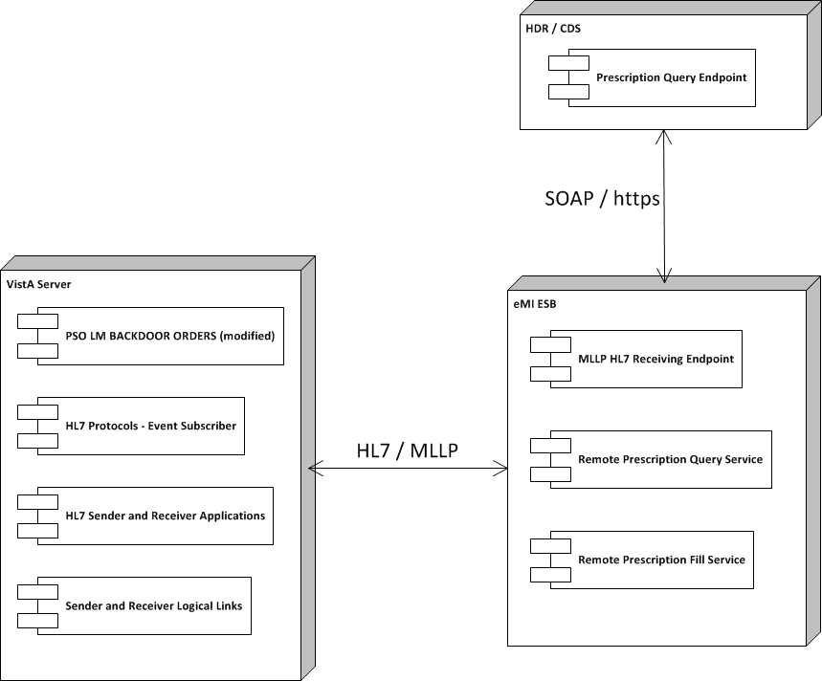

Figure 1: OneVA Pharmacy Design Overview

## Overview of the Business Process

OneVA Pharmacy provides VistA the functionality to allow pharmacists to refill a prescription at any VA pharmacy location. It decrements the patients number of remaining refill balance at the originating pharmacy and manages controlled substances by displaying a message that a controlled substance cannot be refilled outside of the originating pharmacy. The proof-of-concept software will utilize a middleware model that meets the OneVA Technical Reference Model (TRM) list of approved technologies.

## Overview of the Significant Requirements

### Business Rules

Business rules are a high-level functionality condition that the system must support in order to complete the business of the organization. Business rules describe the operations, definitions, and constraints that apply to an organization. The high-level overview of the business rules for OneVA Pharmacy Implementation project includes filtering on only ‘active’ prescriptions with one or more refills remaining and the date of the next refill is no earlier than one week. The prescription cannot be a controlled substance and the patient must be registered in one or more VistAs.

The detailed business rules for the OneVA Pharmacy Implementation project can be found on the VAs installation of the IBM Rational DOORS Next Generation Platform (RDNG) platform under the Pharmacy project in the OneVAPharm team area.

### Design Constraints

Design constraints mandate design decisions that the system must support in order to complete the business of the organization. The high-level overview of the design constraints for the OneVA Pharmacy Implementation project includes using the VistA routine ‘Patient Prescription Processing’ [PSO LM BACKDOOR ORDERS] to access local patient information; HDR/CDS will be used display a medication profile; and the eMI and the VistA Dynamic Host Configuration Protocol (DHCP) HL7 interface for information exchange between VistA systems.

The details for the all design constraints for the OneVA Pharmacy Implementation project can be found on the VAs installation of the IBM Rational DOORS Next Generation Platform (RDNG) platform under the Pharmacy project in the OneVAPharm team area.

### Documentation Specifications

The goal of the ‘Documentation Specifications’ is to ensure necessary documentation is developed according to standard, including the VA Certification and Accreditation process (when applicable). The product documentation includes but is not limited to an Installation Guide, Operations and Maintenance Plan, Technical Manual, User Guide, and Training Manual. Project Management Accountability System (PMAS) Documentation for the One VA Pharmacy Implementation project includes, but is not limited to Risk Issue Log, Requirements Specification Document (RSD), System Design Document (SDD), Initial Operating Capability (IOC) Documentation, Master Test Plan, IOC Site Memorandum of Understanding, Primary Developer Checklist, Secondary Developer Checklist, Requirements Traceability Matrix (RTM), Acceptance Criteria Plan, IOC Entry Request and Exit Summary, Lesson Learned, Contractor Staff Roster, and Training Plan.

The details for all documents required for the OneVA Pharmacy Implementation project can be found on the VAs installation of the IBM Rational DOORS Next Generation Platform (RDNG) platform under the Pharmacy project in the OneVAPharm team area.

### Functional Requirements

A requirement specifies functions that the application should be able to perform and constraints on application performance. The high-level overview functional specifications for OneVA Pharmacy Implementation project includes displaying the Medication Profile for a patient from all other facilities, capability to refill full or partial active prescription for a patient at remote site other than the site the prescription originated frame, dispense local refills as currently designed, generate an Rx label, and generate new reports.

The functional requirements are detailed in the OneVA Pharmacy Implementation RSD which can be found on the VAs installation of the IBM Rational DOORS Next Generation Platform (RDNG) platform under the Pharmacy project in the OneVAPharm team area.

# Conceptual Design

## Conceptual Application Design

The software architecture for the OneVA Pharmacy Implementation project follows the peer-to-peer architectural model, where one VistA node sends and receives data to and from another VistA node. The system utilizes the ESB model providing message routing and coordination of multiple services to view a patient’s prescription record and modify that record in remote VistA systems.

### Application Context

The following diagram displays the VistA application and how it will exist within the design of the ESB model when the OneVA Pharmacy project is implemented.

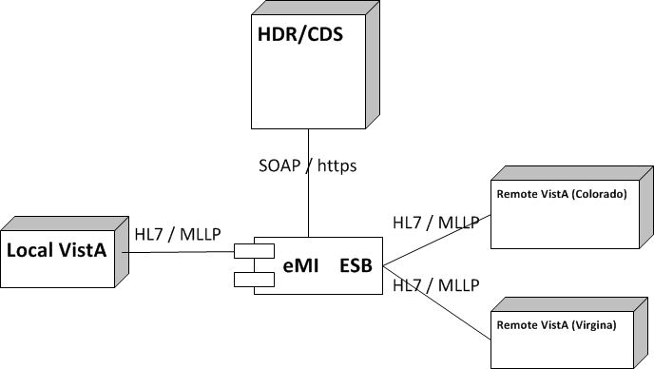

Figure 2: Application Architectural Diagram

The entities displayed in the Application Architecture Diagram are explained as follows:

* VistA is the user interface for initiating prescription queries and requesting prescription refills from remote VistAs.
* eMI ESB is the messaging component to handle MLLP HL7 endpoints, SOAP web service call to the HDR/CDS.

### High-Level Application Design

The High-Level Application Design identifies the major components of the application and the relationships of the major application components to each other. Use cases are being used in this SDD to document the logical application design for the OneVA Pharmacy Implementation project.

The following use cases have the pre-condition that the patient is known and registered in one or more VistAs.

Note: The act of registering a patient in VistA triggers an Admission Discharge Transfer (ADT) registration message to be sent to the Master Veteran Index (MVI) located in the Austin Information Technology Center (AITC). For each new patient, the MVI creates and assigns an Integration Control Number (ICN) and sends this number among other information to the initiating VistA in response to the ADT message. Further the MVI, stores and correlates the local VistA Patient Data File Numbers (DFNs) with the national ICN. One national patient ICN is correlated to (among other systems’ patient identifiers) many local VistA patient identifiers. The ICN enables the sharing of patient data between operationally diverse systems.



Figure 3: High-level Context Diagram

## Use Case Name: View Orders

The ‘View Orders’ use case describes the process for users to view all of a patient’s active prescription orders. This process allows a user to view prescription order information in one place whether the order originated from a local or remote VistA instance.

Actors

* User (Provider, Pharmacist, etc.)
* Local VistA instance
* HDR/CDS
* eMI ESB (proxy to remote VistAs)

Pre-Conditions

* Patient must have an ICN
* User has accessed the PBM Manager Menu [PSU PBM MANAGER MENU] (no separate Security Keys required)

Flow of Events

1. User enters the Medication Profile screen.
2. The local VistA instance will retrieve the local prescriptions.
3. The local VistA instance will send a request via the eMI ESB to the HDR/CDS with the patient identifiers to retrieve the prescriptions with a status of ‘Suspended’, ‘Active’, or ‘Hold’ from all previous treatment facilities excluding local facility.
4. The local VistA instance will display all prescriptions.

Exceptions

* 3a. eMI ESB is not accessible.
* 3b. HDR/CDS is not accessible.

System Message

* 1a. Please wait. Checking for remote prescriptions. This may take a moment…
* 1b. Eligibility: RX PATIENT STATUS: OPT NSC//
* 3a. The system is down or not responding. Could not query remote prescriptions. Press RETURN to continue.

## Use Case Name: Dispense Local Order

The “Dispense Local Order’ use case describes the process for users to dispense local order. Note: Documented in the RSD there is a business requirement that the system shall provide the ability to dispense local refills as currently designed therefore this use case is being presented for test cases development and documentation purpose.

Actors

* User (Provider, Pharmacist, etc.)
* Local VistA Instance

Pre-Conditions

* Patient must have an ICN.
* Local VistA instance has the required amount of prescribed medication inventory on-hand.
* User has accessed the PBM Manager Menu [PSU PBM MANAGER MENU] (no separate Security Keys required

Flow of Events

1. User selects RF (Refill) for a local prescription from the Medication Profile screen.
2. The local VistA will update the prescription; decrement refills, etc.
3. The local VistA will dispense the prescription.

Alternate Flow

1. User selects PF (Partial fill) for a local prescription from the Medication Profile screen.
2. The local VistA will update the prescription; partial fill date, etc.
3. The local VistA will dispense the prescription.

## Use Case Name: Dispense Remote Order

The ‘Dispense Remote Order’ use case describes the process for users to dispense a remote order.

Actors

* User (Provider, Pharmacist, etc.)
* Local VistA Instance
* eMI ESB
* Remote VistA Instance

Pre-Conditions

* Patient must have an ICN.
* Local VistA instance has the required amount of prescribed medication inventory on-hand.
* User has accessed the PBM Manager Menu [PSU PBM MANAGER MENU] (no separate Security Keys required

Flow of Events

1. User selects a remote prescription and RF (Refill) from the Medication Profile screen.
2. The local VistA instance will send a refill order request to the eMI ESB.
3. The eMI ESB will route the refill order request to remote VistA instance.
4. The remote VistA will conduct order checks.
5. The remote VistA will update the prescription order; decrement refills, without affecting inventory.
6. The local VistA instance will dispense medication.

Alternate Flow

1. User selects a remote prescription and PF (Partial fill) from the Medication Profile screen.
2. The local VistA instance will send a partial fill order request to the eMI ESB.
3. The eMI ESB will send partial fill order request to remote VistA instance.
4. The remote VistA will conduct order checks.
5. The remote VistA will update the prescription order; update partial fill date without affecting inventory.
6. The local VistA instance will dispense medication.

Exceptions

* 2a. eMI ESB is not accessible.
* 3a. the remote VistA is not accessible
* 3b. The prescription is a controlled substance
* 4a. The remote VistA instance fails the order.

System Message

* 1a. Please wait. Checking for remote prescriptions. This may take a moment…
* 1b. Eligibility: RX PATIENT STATUS: OPT NSC//
* 3a. The system is down or not responding. Could not query remote prescriptions. Press RETURN to continue.

### Application Locations

The OneVA Pharmacy module extend the existing VistA to provide pharmacists direct access to any active, refillable prescription from any VA Healthcare System. However, additional integration with the VA-eMI middleware and the HDR/CDS repository are part of the deployment deliverables.

As of this writing, the information requested to complete table 7 is not known. As soon as decisions are made available, this documented will be updated accordingly.

Table 7: Application Locations

| Application Component | Description | Location at Which Component is Run | Type |
| --- | --- | --- | --- |
| <Component name> | <Description> | <Facility name> | <Presentation Logic/Business Logic/Data Logic/Interface Code> |

## Conceptual Data Design

### Project Conceptual Data Model

Not applicable.

### Database Information

Not applicable.

### User Interface Data Mapping

Not applicable.

#### Application Screen Interface

Not applicable.

#### Application Report Interface

The system shall provide the ability to generate and print remote prescription reports. There are three reports being developed as part of the OneVA Pharmacy Implementation project. They are:

1. Prescriptions we have filled for other facilities
2. Our prescriptions filled by other facilities
3. All Remote activity

##### Prescriptions we have filled for other facilities

There are three search options available for the ‘Prescriptions we have filled for other facilities’ report. They are:

1. D: Date Range
2. P: Patient
3. S: Site

When selecting ‘D: Date Range’ the user is prompted to enter a start date and end date. The system defaults to 30 days prior to current system date as the start date and the current date as the end date.

When selecting ‘P: Patient’ the user is prompted to specify the patient’s name, social securing number, last four digits of the social security number, or first initial of last name with the last four digits of the social security number.

When selecting ‘S: Site’ the user is promoted to enter a site name, status, station number, official VA name, current location, coding system/id pair, NPI, name (changed from), or coding system.

The following table lists the values displayed on the report.

Table 11: Prescriptions we have filled for other facilities

| Report Column | Data Source |
| --- | --- |
| DATE FILLED | REMOTE PRESCRIPTION LOG FILE (#52.09) – REFILL/PARTIAL DATE (.09) |
| PATEINT | REMOTE PRESCRIPTION LOG FILE (#52.09) – PATIENT (.02) |
| DRUG NAME | REMOTE PRESCRIPTION LOG FILE (#52.09) – LOCAL (MATCHED) DRUG (1.1) |
| TYPE | REMOTE PRESCRIPTION LOG FILE (#52.09) – REQUEST TYPE (.05) |
| QTY | REMOTE PRESCRIPTION LOG FILE (#52.09) – QUANTITY (0.7) |
| DSUP | REMOTE PRESCRIPTION LOG FILE (#52.09) – DAYS SUPPLY (.08) |

The following image displays the remote report example.

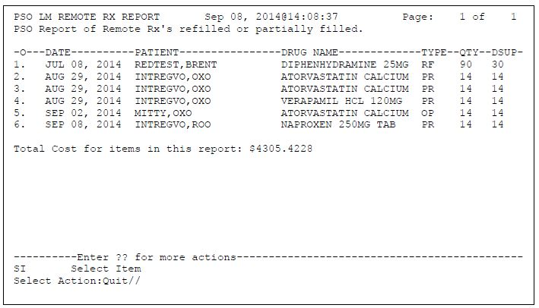

Figure 4: Remote Report Content Example

##### Our prescriptions, filled by other facilities

There are three search options available for the ‘Our prescriptions, filled by other facilities’ report. They are:

1. D: Date Range
2. P: Patient
3. S: Site

When selecting ‘D: Date Range’ the user is prompted to enter a start date and end date. The system defaults to 30 days prior to current system date as the start date and the current date as the end date.

When selecting ‘P: Patient’ the user is prompted to specify the patient’s name, social securing number, last four digits of the social security number, or first initial of last name with the last four digits of the social security number.

When selecting ‘S: Site’ the user is promoted to enter a site name, status, station number, official VA name, current location, coding system/id pair, NPI, name (changed from), or coding system.

The following table lists the values displayed on the report.

Table 11: Our prescriptions, filled by other facilities

| Report Column | Data Source |
| --- | --- |
| DATE FILLED | REMOTE PRESCRIPTION LOG FILE (#52.09) – REFILL/PARTIAL DATE (.09) |
| PATEINT | REMOTE PRESCRIPTION LOG FILE (#52.09) – PATIENT (.02) |
| DRUG NAME | REMOTE PRESCRIPTION LOG FILE (#52.09) – LOCAL (MATCHED) DRUG (1.1) |
| TYPE | REMOTE PRESCRIPTION LOG FILE (#52.09) – REQUEST TYPE (.05) |
| QTY | REMOTE PRESCRIPTION LOG FILE (#52.09) – QUANTITY (0.7) |
| DSUP | REMOTE PRESCRIPTION LOG FILE (#52.09) – DAYS SUPPLY (.08) |

The following image displays the remote report example.



Figure 5: Remote Report Content Example

##### All Remote activity

There are three search options available for the ‘All Remote activity’ report. They are:

1. D: Date Range
2. P: Patient
3. S: Site

When selecting ‘D: Date Range’ the user is prompted to enter a start date and end date. The system defaults to 30 days prior to current system date as the start date and the current date as the end date.

When selecting ‘P: Patient’ the user is prompted to specify the patient’s name, social securing number, last four digits of the social security number, or first initial of last name with the last four digits of the social security number.

When selecting ‘S: Site’ the user is promoted to enter a site name, status, station number, official VA name, current location, coding system/id pair, NPI, name (changed from), or coding system.

The following table lists the values displayed on the report.

Table 11: All Remote activity

| Report Column | Data Source |
| --- | --- |
| DATE FILLED | REMOTE PRESCRIPTION LOG FILE (#52.09) – REFILL/PARTIAL DATE (.09) |
| PATEINT | REMOTE PRESCRIPTION LOG FILE (#52.09) – PATIENT (.02) |
| DRUG NAME | REMOTE PRESCRIPTION LOG FILE (#52.09) – LOCAL (MATCHED) DRUG (1.1) |
| TYPE | REMOTE PRESCRIPTION LOG FILE (#52.09) – REQUEST TYPE (.05) |
| QTY | REMOTE PRESCRIPTION LOG FILE (#52.09) – QUANTITY (0.7) |
| DSUP | REMOTE PRESCRIPTION LOG FILE (#52.09) – DAYS SUPPLY (.08) |

The following image displays the remote report example.



Figure 6: Remote Report Content Example

#### Unmapped Data Element

Not applicable.

## Conceptual Infrastructure Design

The OneVA Pharmacy Implementation project introduces the VA-eMI ESB and calls to the HDR/CDS repository. The following diagram depicts the flow of the additional components being introduced in the VistA environment.

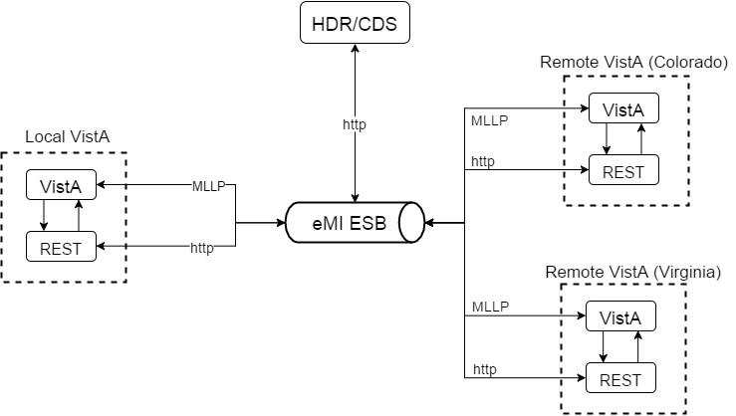

Figure 7: OneVA Pharmacy Components

### System Criticality and High Availability

The OneVA Pharmacy extends the VistA application and will incorporate by default the same rules of engagement as VistA.

### Special Technology

The OneVA Pharmacy engages the VAeMI-Middleware components and the HDR/CDS repository. They are:

* Integration Bus (IB) v9 – the ESB supplied by the VA
* HCP: Healthcare Connectivity Pack (HCP) – contains the HL7 API and other health-related software to run in the ESB, also supplied by VA
* Message Broker (MQ) – A message queue that will handle messages passed into the ESB, also supplied by VA
* Integration toolkit – the development environment in which our solution is coded

Table 12: Special Technology Requirements

| Special Technology | Description | Notional Location | TRM Status |
| --- | --- | --- | --- |
| Integration Bus (IB) v9 | IBM’s ESB supplied by the VA | Application Server | Yes |
| HCP: Healthcare Connectivity Pack (HCP) | Supports HL7 data flows | Integrated into the ESB | Yes |
| Message Broker (MQ) | IBM’s message queue that will handle messages passed into the ESB for reliable messaging | Application Server | Yes |
| Integration toolkit | the development environment in which our solution is coded | Not for production deployment |  |

### Technology Locations

TBD

This section describes the various technology components that will be used. If known, provide the name of the datacenter at which the technology will be installed. If not, specify as Site A, Site B etc. Provide this information in Table 13.

Table 13: Technology Location Details

| Technology Component  Production 1 | Location | Usage |
| --- | --- | --- |
| Workstations |  |  |
| Special Hardware |  |  |
| Interface Processors |  |  |
| Legacy Mainframe |  |  |
| Legacy Application Server |  |  |
| Legacy Databases |  |  |
| Other |  |  |

| Technology Component  Production 2 | Location | Usage |
| --- | --- | --- |
| <copy from Prod 1 set, or enter new ones as appropriate> |  |  |

| Technology Component  Certification | Location | Usage |
| --- | --- | --- |
|  |  |  |

| Technology Component  Education | Location | Usage |
| --- | --- | --- |
|  |  |  |

| Technology Component  Test | Location | Usage |
| --- | --- | --- |
|  |  |  |

| Technology Component  Development | Location | Usage |
| --- | --- | --- |
|  |  |  |

### Conceptual Infrastructure Diagram

#### Location of Environments and External Interfaces

TBD

Create a diagram to show the environments that will be supported. As illustrated in Figure 8, the diagram should show the following:

* Local networks to which they will be attached (Production, Test, or Development)
* Locations at which they will be installed
* External connections (each external interface should be shown in terms of where it enters the network).

Figure 8: Sample Conceptual Networks and Environments

#### Conceptual Production String Diagram

TBD

Create a diagram to show the configuration of a single production string.

Additional components, such as the mainframe, other Web servers, or other major components should be included if they are expected to be required.

# System Architecture

## Hardware Architecture

TBD

## Software Architecture

### eMI ESB

The eMI ESB is responsible for message passing, routing and transformation. By utilizing several communication protocols and handing various message format, the eMI ESB is the backbone of the system. This system contains the following features described below. MLLP HL7 Endpoint

An MLLP Service will handle all incoming MLLP HL7 v2.x requests. The requests will be routed based on the message type and trigger event (MSH-10). The MLLP Service will route the following messages to the appropriate service:

Table 2: MLLP HL7 Endpoint Messages

| Message | Response | Description | Service Reference |
| --- | --- | --- | --- |
| QBP^Q13 | KTB^K13 | Query by parameter |  |
| RDS^O13 | RRD^O14 | Pharmacy/Treatment Dispense Message |  |

### HDR/CDS Endpoint

The eMI ESB will handle QBP-Q13 HL7 query requests to the HDR/CDS to retrieve a patient’s list of active prescriptions. The response will be in a JSON format which will be transformed into an HL7 v2.x RTB-K13 message with tabular data containing aggregated, active prescription information in the remote VistAs.

### Sequence Diagrams

The next sub-sections show the sequence of event among key entities when the Use Cases are being executed.

#### View Order

The figure below shows two (2) VistAs. The remote VistA has refillable prescription order at some point in the past. The local VistA on the left is system currently in use by the end user. The local VistA is where the patient is physically located at the time the refill is requested. The provider will view all the active prescriptions. This will send a request to the HDR/CDS which has all active prescriptions in other VistA systems for the patient. When this result is combined with the current prescriptions, the user has the complete prescription orders for the patient.

| Use Case: View Orders |
| --- |
| The image displays the View Order Use Case. |

Figure 9: View Order Sequence diagram

#### Dispense Remote Order Sequence Diagram

Order displays the sequence of events to dispense a remote order. Like the sequence diagram above, an order was created for the patient at a remote VistA system. The user will view all active prescriptions for the patient and selects an active prescription from a remote VistA. Selecting that prescription and executing the fill order request, the system will send a message to the eMI ESB, which then routes the request to the correct remove VistA instance. This request will then decrement the prescription count, but will not affect the inventory of the remote facility. When the decrement is successful, that successful result is communicated back to the local VistA instance so that the prescription can be dispensed locally and a label is printed out.

| **Use Case: Dispense Local Order** |
| --- |
| The image displays the Dispense Remote Orders Use Case architectural layout. |

Figure 10: Dispense Remote Order Sequence diagram

### Design Rationale

The whole basis of this project is to allow standalone VistA system to send messages and affect each other’s state. This means message routing and transformation. By leveraging the VA’s overall goals to provide an enterprise system-to-system communication platform, the eMI ESB, this project can expose key functionality in VistA systems that will allow providers a higher level of care to patients. This also means leveraging system-wide information that has been collected into repositories like the HDR/CDS. Instead of querying each system individually, which can potentially be inefficient and fraught with lost communication, a single repository can be queried. The last piece of this system is the ESB to VistA communication. This is always the pain-point when dealing with any legacy system. The current implementation of the system uses Intrasystem’s Global API to execute VistA MUMPs commands. This API is required to be on the same machine as the VistA system.

### HL7 Protocol

The communication protocol used between components is HL7 v2. x. HL7 v2.x is a standard messaging protocol used to communicate among health information systems. Additionally, MyHealtheVet, a predecessor VA application, uses an HL7 v2 QBP-Q13 message to query prescriptions from VistA.

## Network Architecture

## Service Oriented Architecture / ESS

The following diagram displays the VistA application and how it will exist within the design of the ESB model.



Figure 11: VistA and eMI ESB Integration

The entities displayed in the Application Architecture Diagram are explained as follows:

* VistA is the user interface for initiating prescription queries and requesting prescription refills from remote VistAs.
* eMI ESB is the messaging component to handle MLLP HL7 endpoints and the HDR/CDS.



Figure 12: HL7/MLLP and SOAP/https Integration

## Enterprise Architecture

The Enterprise Architecture of OneVA Pharmacy consists of three main components. They are:

1. VistA
2. VA’s eMI ESB (for communication)
3. HDR/CDS

To use an example to explain the architecture, a Pharmacist at one VA facility will use VistA to display all the prescriptions for a Veteran that originated at another VA facility. In order to display all of the active prescriptions the HDR/CDS will be used to accumulate all prescriptions. The local VistA instance will send an HL7 message over MLLP via the *Sender and Receiver Logical links* to the eMI ESBs *MLLP HL7 Receiving endpoint*. The ESB will transform the HL7 message into a SOAP request over https to the HDR via the *Remote Prescription Query Service*. The SOAP response from the HDR/CDS is transformed into an HL7 message and sent as a response to the calling VistA instance. The VistA instance will display the entire prescription record for the user. Once the Pharmacist selects a prescription from a remote VistA to refill a prescription, another message is generated and sent to the ESB. The ESB will detect that the message is a prescription fill request and then route the message to the destination VistA. The remote VistA instance receives the message on it’s logical link and performs the necessary decrement to the patient’s prescription refill allotment without affecting the remote facilities inventory.

# Data Design

## DBMS Files

### Refill Multiple (#52.1) of the Prescription File (#52)

| Field Number | Field Name | Pointers | Cross References and Record Indices | Description |
| --- | --- | --- | --- | --- |
| 91 | Remote Fill Site | Institution File (#4) | “RFIL” | This is the site that performed the remote refill action. |
| 92 | Remote Pharmacist | N/A | N/A | This is the name of the remote pharmacist that performed the refill action. |
| 93 | Remote Pharmacist Phone | N/A | N/A | This is the phone number for the pharmacist that performed the refill action. |

### Partial Multiple (#52.2) of the Prescription File (#52)

| Field Number | Field Name | Pointers | Cross References and Record Indices | Description |
| --- | --- | --- | --- | --- |
| 91 | Remote Fill Site | Institution File (#4) | “RFIL” | This is the site that performed the remote partial fill action. |
| 92 | Remote Pharmacist | N/A | N/A | This is the name of the remote pharmacist that performed the partial fill action. |
| 93 | Remote Pharmacist Phone | N/A | N/A | This is the phone number for the pharmacist that performed the partial fill action. |

### Remote Prescription Log (#52.09)

| Field Number | Field Name | Pointers | Cross References and Record Indices | Description |
| --- | --- | --- | --- | --- |
| .01 | LOG DATE/TIME | N/A | 52.09^B | Date/Time of refill/partial fill transaction. |
| .02 | PATIENT | PATIENT (#2) | 52.09^C | This is the patient for which a refill or partial fill was executed remotely. |
| .03 | RX NUMBER | N/A | 52.9^D | This is the RX Number from the prescription file (#52). ** Should this be converted to a pointer??** |
| .04 | SITE NUMBER | INSTITUTION (#4) | 5209^E |  |
| .05 | REQUEST TYPE | N/A |  | RF – REFILL  PR – PARTIAL FILL  OR – OUTSIDE REFILL  OP – OUTSIDE PARTIAL FILL |
| .06 | OUTGOING REQUEST PHARMACIST | NEW PERSON (#200) | N/A | This is the pharmacist who initiated the refill or partial fill request to the remote facility |
| .061 | REMOTE FILLING PHARMACIST | N/A | N/A | This is the pharmacist that requested a refill or partial fill from a remote facility. |
| .07 | QUANTITY | N/A | N/A | This is the quantity dispensed. |
| .08 | DAYS SUPPLY | N/A | N/A | This is the day’s supply for the medication. |
| .09 | REFILL/PARTIAL DATE | N/A | N/A | This is the date of the refill or partial fill request. This represents the date as it is logged in the .01 field of either the refill or partial sub files within the prescription file. |
| .1 | DISPENSED DATE | N/A | N/A | This is the Dispense date as it is held in the DISPENSED DATE within the REFILL or PARTIAL sub files of the PRESCRIPTION file. |
| 1 | REMOTE DRUG NAME | N/A | N/A | This is the name of the drug being dispensed for this request.** Note, we may want both the name and VA product id..*** |
| 1.1 | LOCAL (MATCHED) DRUG | DRUG (#50) | N/A | This is the drug that was used locally for the ‘remote’ refill or partial fill. |
| 1.2 | TOTAL REFILL/PARTIAL FILL COST | N/A | N/A | This is the total cost for the ‘remote’/filling facility. The cost is derived by using the cost of the drug at the time of the refill or partial fill. The cost is being retrieved from file 50, field 13. |
| 2 | MESSAGE DETAILS | N/A | N/A | Any message details related to the transaction. |
| 3 | LABEL DATA | N/A | N/A | Label data word processing field. |

## Non-DBMS Files

Not applicable.

## Data View

Not applicable.

# Detailed Design

## Hardware Detailed Design

Not applicable.

## Software Detailed Design

TBD

### Conceptual Design

#### Product Perspective

The OneVA Pharmacy extends the existing VistA, specifically Patient Prescription Processing [PSO LM BACKDOOR ORDERS] to provide pharmacists direct access to any active, refillable prescription from any VA Healthcare System.

##### User Interfaces

The OneVA Pharmacy extends the existing VistA application so the user interface is the VistA [PSO LM BACKDOOR ORDERS].

##### Hardware Interfaces

The hardware interface will utilize the existing architecture found within the VA Enterprise.

##### Software Interfaces

Not applicable.

##### Communications Interfaces



Figure 13: Communications Interface

##### Memory Constraints

Not applicable.

##### Special Operations

Not applicable.

#### Product Features

The OneVA Pharmacy Implementation at a high level includes:

* VistA Patch PSO*7*454
  + PSO LM BACKDOOR ORDERS
* VAeMI-Middleware
* Connectivity to the Health Data Repository/ Clinical Data Services (HDR/CDS) via the Enterprise Service Bus (eMI)
* Validation of Health Level 7 (HL7) messages

#### User Characteristics

The user profile of the OneVA Pharmacy module are those users, specifically pharmacists, that use the Pharmacy [PSO LM BACKDOOR ORDERS] menu to dispense prescriptions.

#### Dependencies and Constraints

TBD

### Specific Requirements

#### Database Repository

Not applicable.

#### System Features

The system features include functional requirements, sub-requirements, business rules, design constraints, etc. and are organized in a Requirements Specification Document (RSD). The OneVA Pharmacy Implementation projects RSD can be found in the VAs installation of the IBM Rational DOORS Next Generation Platform (RDNG) platform under the Pharmacy project in the OneVAPharm team area.

#### Design Element Tables

Not applicable.

##### Routines (Entry Points)

###### PSOORNE2

The ‘PSOORNE2’ routine has been modified to include the display of the remote prescriptions. This routine will display the details related to the remote Rx that has been selected.

Table 15 (Grouping): Routines

| Routines | Activities | | | |
| --- | --- | --- | --- | --- |
| **Routine Name** | PSOORNE2 | | | |
| **Enhancement Category** | New | Modify | Delete | No Change |
| **RTM** |  | | | |
| **Related Options** | PSO LM BACKDOOR ORDERS | | | |

| Related Routines | Routines “Called By” | Routines “Called” |
| --- | --- | --- |
|  | PSODISPS, PSOLMUTL, PSOMPHRC, PSOORCPY, PSOOREDT, PSOREF, PSORREF, PSORXEDT | PSOORNE6, PSOVER1, PSORRX1, PSOBUILD, PSOORUT1, PSODRG, PSOORNE5, PSONFI, PSOBPSUT, PSOHELP, PSOUTLA2, PSOORNE3, PSODAWUT, PSSDAWUT, PSOLMLST, PSOROS |

| Routines | Activities | | | | |
| --- | --- | --- | --- | --- | --- |
| **Data Dictionary (DD) References** | ^PSDRUG(  ^YSCL(603.01,  ^PS(50.606,  ^PS(50.7,  ^PS(52.5  ^PSRX(  ^DIC(4, | | | | |
| **Related Protocols** | N/A | | | | |
| **Related Integration Control Registrations (ICRs)** | 4708 – Call to DAWEXT^PSSDAWUT (Active/Controlled Subscription) | | | | |
| **Data Passing** | Input | Output Reference | Both | Global Reference | Local |
| **Input Attribute Name and Definition** | Name: N/A  Definition: | | | | |
| **Output Attribute Name and Definition** | Name: N/A  Definition: | | | | |

| Current Logic |
| --- |
| Cannot get current logic until we have all patches associated with this routine. |

| Modified Logic (Changes are in bold) |
| --- |
|  |

###### PSOORUT1

The ‘PSOORUT1’ routine has been modified to include the display of remote prescriptions within the [PSO LM BACKDOOR ORDER] prescription list. The prescriptions are sorted by facility and include the same display elements at eh local prescription. Each remote facility’s prescription list has a programmatically generated header that separates the prescriptions by status (Active, Suspended, Hold, etc.)

| Routines | Activities | | | |
| --- | --- | --- | --- | --- |
| **Routine Name** | PSOORUT1 | | | |
| **Enhancement Category** | New | Modify | Delete | No Change |
| **RTM** |  | | | |
| **Related Options** | PSO LM BACKDOOR ORDERS | | | |

| Related Routines | Routines “Called By” | Routines “Called” |
| --- | --- | --- |
|  | PSOCAN4, PSODISP3, PSOHLNEW, PSOLMUTL, PSONEW, PSOORFI2, PSOORFL, PSOORNE2, PSOORUTL, PSOREF, PSORENW4, PSORX1, PSOTPRX1, PSOVER | %DTC,DICN, DIK, DIQ, PSOBPSU1, PSOBPSUT, PSOHLSN1,PSOORUTL, PSOREJUT, PSOUTL, |

| Routines | Activities | | | | |
| --- | --- | --- | --- | --- | --- |
| **Data Dictionary (DD) References** | ^PS(52.41,  ^PSRX(  ^PS(52.5,  ^DIC(4, | | | | |
| **Related Protocols** |  | | | | |
| **Related Integration Control Registrations (ICRs)** | IA #221 – Access to ^PSDRUG  IA #2203 – Call to ^PSXOPUTL | | | | |
| **Data Passing** | Input | Output Reference | Both | Global Reference | Local |
| **Input Attribute Name and Definition** | Name: N/A  Definition: N/A | | | | |
| **Output Attribute Name and Definition** | Name: N/A  Definition: N/A | | | | |

| Current Logic |
| --- |
| Cannot get current logic until we have all patches associated with this routine. |

| Modified Logic (Changes are in bold) |
| --- |
|  |

###### PSOROS

The ‘PSOROS’ routine is the driving routine for selection of a ‘remote’ prescription within list manager. This routine controls the list template [PSO LM REMOTE ORDER SELECTION].

| Routines | Activities | | | |
| --- | --- | --- | --- | --- |
| **Routine Name** | PSOROS | | | |
| **Enhancement Category** | New | Modify | Delete | No Change |
| **RTM** |  | | | |
| **Related Options** |  | | | |

| Related Routines | Routines “Called By” | Routines “Called” |
| --- | --- | --- |
|  |  | VALM, PSONFI, XQORM1 |

| Routines | Activities | | | | |
| --- | --- | --- | --- | --- | --- |
| **Data Dictionary (DD) References** |  | | | | |
| **Related Protocols** | PSO LM REMOTE ORDER MENU  PSO LM REFILL REMOTE ORDER  PSO LM REMOTE PARTIAL | | | | |
| **Related Integration Control Registrations (ICRs)** | N/A | | | | |
| **Data Passing** | Input | Output Reference | Both | Global Reference | Local |
| **Input Attribute Name and Definition** | Name: N/A  Definition: N/A | | | | |
| **Output Attribute Name and Definition** | Name: N/A  Definition: N/A | | | | |

| Current Logic |
| --- |
| N/A |

|  |  |  |  |  |  |  |  |  |  |  |  |  |  |  |  |  |  |  |  |  |  |  |  |  |  |  |  |
| --- | --- | --- | --- | --- | --- | --- | --- | --- | --- | --- | --- | --- | --- | --- | --- | --- | --- | --- | --- | --- | --- | --- | --- | --- | --- | --- | --- |
| | Modified Logic (Changes are in bold) | | --- | |  |  PSORRD The ‘PSORRD’ routine is the routine that controls the PSO LM REMOTE REPORTS DETAILS list manager template. This routine is part of the Remote Prescription Report functionality.   | Routines | Activities | | | | | --- | --- | --- | --- | --- | | **Routine Name** | PSORRD | | | | | **Enhancement Category** | New | Modify | Delete | No Change | | **RTM** |  | | | | | **Related Options** |  | | | | |

| Related Routines | Routines “Called By” | Routines “Called” |
| --- | --- | --- |
|  |  | VALM, XQORM1 |

| Routines | Activities | | | | |
| --- | --- | --- | --- | --- | --- |
| **Data Dictionary (DD) References** | N/A | | | | |
| **Related Protocols** | N/A | | | | |
| **Related Integration Control Registrations (ICRs)** | N/A | | | | |
| **Data Passing** | Input | Output Reference | Both | Global Reference | Local |
| **Input Attribute Name and Definition** | Name:  Definition: | | | | |
| **Output Attribute Name and Definition** | Name:  Definition: | | | | |

| Current Logic |
| --- |
| N/A |

|  |  |  |  |  |  |  |
| --- | --- | --- | --- | --- | --- | --- |
| | Modified Logic (Changes are in bold) | | --- | |  |  PSORREF The ‘PSORREF’ routine is the main driving routine for the ‘receiving’ or ‘originating’ facility to process incoming refill requests. | | | | |
| Routines | Activities | | | |
| **Routine Name** | PSORREF | | | |
| **Enhancement Category** | New | Modify | Delete | No Change |
| **RTM** |  | | | |
| **Related Options** | PSO LM BACKDOOR ORDERS | | | |

| Related Routines | Routines “Called By” | Routines “Called” |
| --- | --- | --- |
|  |  | %DTC, %ZISH, DIE, DIQ, PSOBUILD, PSOCPTRI, PSOREJU1, PSORREF0, PSORREF1, PSORRX1, PSSLOCK, XLFDT, XUAF4 |

| Routines | Activities | | | | |
| --- | --- | --- | --- | --- | --- |
| **Data Dictionary (DD) References** | ^PSRX(  %ZIS(1,  ^PS(55, | | | | |
| **Related Protocols** | N/A | | | | |
| **Related Integration Control Registrations (ICRs)** | Need to see if we need any IA’s | | | | |
| **Data Passing** | Input | Output Reference | Both | Global Reference | Local |
| **Input Attribute Name and Definition** | Name: RXNUM  Definition: Prescription Number  Name: FDATE  Definition: Fill Date  Name: MW  Definition: Mail/Window  Name: RPHARM  Definition: Remote Pharmacists Name  Name: RPHONE  Definition: Remote Pharmacists Telephone Number  Name: RISTE  Definition: Remote site requesting the refill | | | | |
| **Output Attribute Name and Definition** | Name: RET  Definition: Return array “Rx # xxxxx refilled.”, or error message. | | | | |

| Current Logic |
| --- |
| N/A |

|  |  |  |  |  |  |  |
| --- | --- | --- | --- | --- | --- | --- |
| | Modified Logic (Changes are in bold) | | --- | |  |  PSORREF0 The ‘PSORREF0’ is a supporting routine to ‘PSORREF’. | | | | |
| Routines | Activities | | | |
| **Routine Name** | PSORREF0 | | | |
| **Enhancement Category** | New | Modify | Delete | No Change |
| **RTM** |  | | | |
| **Related Options** | PSO LM BACKDOOR ORDERS | | | |

| Related Routines | Routines “Called By” | Routines “Called” |
| --- | --- | --- |
|  | PSORREF1 | %DT, DIR, PSOPTPST, PSOR52, PSOREF1, PSOREF2, PSOUTIL, PSOUTLA, PSOUTLA1, VALM1 |

| Routines | Activities | | | | |
| --- | --- | --- | --- | --- | --- |
| **Data Dictionary (DD) References** | ^PSRX | | | | |
| **Related Protocols** |  | | | | |
| **Related Integration Control Registrations (ICRs)** | Will need to get included in IA 221 | | | | |
| **Data Passing** | Input | Output Reference | Both | Global Reference | Local |
| **Input Attribute Name and Definition** | Name:  Definition: | | | | |
| **Output Attribute Name and Definition** | Name: PSORMSG  Definition: Output message containing information about the refill request. | | | | |

| Current Logic |
| --- |
| N/A |

|  |  |  |  |  |  |  |
| --- | --- | --- | --- | --- | --- | --- |
| | Modified Logic (Changes are in bold) | | --- | |  |  PSORREF1 The ‘PSORREF1’ is a supporting routine for ‘PSORREF’. | | | | |
| Routines | Activities | | | |
| **Routine Name** | PSORREF1 | | | |
| **Enhancement Category** | New | Modify | Delete | No Change |
| **RTM** |  | | | |
| **Related Options** | PSO LM BACKDOOR ORDERS | | | |

| Related Routines | Routines “Called By” | Routines “Called” |
| --- | --- | --- |
|  | PSORREF | %DT |

| Routines | Activities | | | | |
| --- | --- | --- | --- | --- | --- |
| **Data Dictionary (DD) References** | ^PSRX | | | | |
| **Related Protocols** | N/A | | | | |
| **Related Integration Control Registrations (ICRs)** | N/A | | | | |
| **Data Passing** | Input | Output Reference | Both | Global Reference | Local |
| **Input Attribute Name and Definition** | N/A | | | | |
| **Output Attribute Name and Definition** | N/A | | | | |

| Current Logic |
| --- |
| N/A |

|  |  |  |  |  |  |  |
| --- | --- | --- | --- | --- | --- | --- |
| | Modified Logic (Changes are in bold) | | --- | |  |  PSORRP The ‘PSORRP’ routine assists in prompting for search criteria and display of the Remote Prescription Report. | | | | |
| Routines | Activities | | | |
| **Routine Name** | PSORRP | | | |
| **Enhancement Category** | New | Modify | Delete | No Change |
| **RTM** |  | | | |
| **Related Options** | PSO REMOTE RX REPORT | | | |

| Related Routines | Routines “Called By” | Routines “Called” |
| --- | --- | --- |
|  | N/A | %DT, DIC, DIQ, DIR, PSOROS, PSORRD, VALM, VALM1, VALM10, XLFDT, XQORM1 |

| Routines | Activities | | | | |
| --- | --- | --- | --- | --- | --- |
| **Data Dictionary (DD) References** | ^PSRXR(52.09, | | | | |
| **Related Protocols** |  | | | | |
| **Related Integration Control Registrations (ICRs)** | N/A | | | | |
| **Data Passing** | Input | Output Reference | Both | Global Reference | Local |
| **Input Attribute Name and Definition** | N/A | | | | |
| **Output Attribute Name and Definition** | N/A | | | | |

| Current Logic |
| --- |
| N/A |

|  |  |  |  |  |  |  |
| --- | --- | --- | --- | --- | --- | --- |
| | Modified Logic (Changes are in bold) | | --- | |  |  PSORRPA1 The ‘PSORRPA1’ is the main routine for processing an incoming partial fill request. | | | | |
| Routines | Activities | | | |
| **Routine Name** | PSORRPA1 | | | |
| **Enhancement Category** | New | Modify | Delete | No Change |
| **RTM** |  | | | |
| **Related Options** | PSO LM BACKDOOR ORDERS | | | |

| Related Routines | Routines “Called By” | Routines “Called” |
| --- | --- | --- |
|  | N/A | %ZISH, DIE, DIK, DIQ, PSOBPSUT, PSOCAN3, PSOCPTRI, PSOHLSN1, PSORRX1, PSORXL1, PSSLOCK, VADPT, XLFDT, XUAF4 |

| Routines | Activities | | | | |
| --- | --- | --- | --- | --- | --- |
| **Data Dictionary (DD) References** | ^PSRX(  ^PS(59,  ^PS(52.5,  ^%ZIS(1,  ^PS(55, | | | | |
| **Related Protocols** |  | | | | |
| **Related Integration Control Registrations (ICRs)** | IA 221?  IA 999?? | | | | |
| **Data Passing** | Input | Output Reference | Both | Global Reference | Local |
| **Input Attribute Name and Definition** | Name: RXNUM  Definition:  Name: PFDATE  Definition: Partial fill date  Name: MW  Definition: Mail/Window  Name: QTY  Definition: Quantity  Name: DSUPP  Definition: Days supply  Name: REMARKS  Definition: Remarks (if applicable)  Name: PHARM  Definition: Name of Filling pharmacist (remote)  Name: PHONE  Definition: Phone number of remote pharmacist  Name: SITE  Definition: Remote Site number | | | | |
| **Output Attribute Name and Definition** | Name: VALMSG  Definition: Response message for partial fill | | | | |

| Current Logic |
| --- |
| N/A |

|  |  |  |  |  |  |  |
| --- | --- | --- | --- | --- | --- | --- |
| | Modified Logic (Changes are in bold) | | --- | |  |  PSORRX1 The ‘PSORRX1’ routine builds the HL7 messages that are sent to the Pharmacy Remote Prescription Manager to retrieve, refill, and partial fill prescriptions from another facility. This routine uses the treating facility list to properly build the HL7 information to send to the ‘remote’ site(s). | | | | |
| Routines | Activities | | | |
| **Routine Name** | PSORRX1 | | | |
| **Enhancement Category** | New | Modify | Delete | No Change |
| **RTM** |  | | | |
| **Related Options** | PSO LM BACKDOOR ORDERS | | | |

| Related Routines | Routines “Called By” | Routines “Called” |
| --- | --- | --- |
|  | PSORX1 | %ZIS, DIC, DIE, DILFD, DIQ, DIR, HLFNC2, HLMA, PSODIR2, VAFCTFU2, VALM1, XLFDT, XUAF4 |

| Routines | Activities | | | | |
| --- | --- | --- | --- | --- | --- |
| **Data Dictionary (DD) References** |  | | | | |
| **Related Protocols** |  | | | | |
| **Related Integration Control Registrations (ICRs)** |  | | | | |
| **Data Passing** | Input | Output Reference | Both | Global Reference | Local |
| **Input Attribute Name and Definition** | Name: DFN  Definition: Patients local IEN | | | | |
| **Output Attribute Name and Definition** | HL7 MESSAGE IN HL7 QUEUE | | | | |

| Current Logic |
| --- |
| N/A |

|  |  |  |  |  |  |  |
| --- | --- | --- | --- | --- | --- | --- |
| | Modified Logic (Changes are in bold) | | --- | |  |  PSORWRAP The ‘PSORWRAP’ routine is the wrapper utility for the RESTful calls into VistA. | | | | |
| Routines | Activities | | | |
| **Routine Name** | PSORWRAP | | | |
| **Enhancement Category** | New | Modify | Delete | No Change |
| **RTM** |  | | | |
| **Related Options** | N/A | | | |

| Related Routines | Routines “Called By” | Routines “Called” |
| --- | --- | --- |
|  | N/A | PSORREF, PSORRPA1, XLFDT, XUP |

| Routines | Activities | | | | |
| --- | --- | --- | --- | --- | --- |
| **Data Dictionary (DD) References** | N/A | | | | |
| **Related Protocols** | N/A | | | | |
| **Related Integration Control Registrations (ICRs)** | N/A | | | | |
| **Data Passing** | Input | Output Reference | Both | Global Reference | Local |
| **Input Attribute Name and Definition** | Name: QBSESSID  Definition: Session ID  Name: QBDUZ  Definition: Users DUZ value | | | | |
| **Output Attribute Name and Definition** | Name: Status  Definition: returns session id and 1 if successful | | | | |

| Current Logic |
| --- |
| N/A |

|  |  |  |  |  |  |  |
| --- | --- | --- | --- | --- | --- | --- |
| | Modified Logic (Changes are in bold) | | --- | |  |  PSORX1 The ‘PSORX1’ routine has been modified to call ‘PSORRX1’ for retrieval of remote prescription data. | | | | |
| Routines | Activities | | | |
| **Routine Name** | PSORX1 | | | |
| **Enhancement Category** | New | Modify | Delete | No Change |
| **RTM** |  | | | |
| **Related Options** |  | | | |

| Related Routines | Routines “Called By” | Routines “Called” |
| --- | --- | --- |
|  |  | DTC, $ZISS, DGPFAPI, DIC, DICN, DIE, DIK, DIQ1, DIR, ORRDI1, PSOBAI, PSOBING, PSOBUILD, PSODDPR2, PSODEM, PSOHLUP, PSOLMAO, PSOLMUTL, PSOLSET, PSOORFI2, PSOORUT1, PSOORUT2, PSOPATLK, PSOPTPST, PSORMRX, PSORRX1, PSORXL, PSOSUPOE, PSUHL, VADPT, VALM1 |

| Routines | Activities | | | | |
| --- | --- | --- | --- | --- | --- |
| **Data Dictionary (DD) References** | ^PS(55,  ^DIC(31,  ^DPT(DO,.372,  ^XTMP(“ORRDI”  ^PSUHL  ^PSRX | | | | |
| **Related Protocols** | N/A | | | | |
| **Related Integration Control Registrations (ICRs)** | External reference ^PS(55 supported by DBIA 2228  External reference ^DIC(31 supported by DBIA 658  external reference ^DPT(D0,.372 supported by DBIA 1476  External reference DISPPRF^DGPFAPI supported by DBIA #4563  External reference ^ORRDI1 is supported by DBIA 4659  External reference ^XTMP("ORRDI" is supported by DBIA 4660  External reference ^PSUHL supported by DBIA 4803 | | | | |
| **Data Passing** | Input | Output Reference | Both | Global Reference | Local |
| **Input Attribute Name and Definition** | N/A | | | | |
| **Output Attribute Name and Definition** | N/A | | | | |

| Current Logic |
| --- |
| Cannot get current logic until we have all patches associated with this routine. |

|  |  |  |
| --- | --- | --- |
| | Modified Logic (Changes are in bold) | | --- | |  | |

##### Templates

###### PSO LM REMOTE ORDER SELECTION

The ‘PSO LM REMOTE ORDER SELECTION’ provides the logic needed to display a remote prescription within PSO LM BACKDOOR ORDERS.

| Templates | Description | | | |
| --- | --- | --- | --- | --- |
| **Template Name** | PSO LM REMOTE ORDER SELECTION | | | |
| **Enhancement Category** | New | Modify | Delete | No Change |
| **RSD** |  | | | |
| **Template Type** | Sort | Input | Print | Other |
| **Related Options** |  | | | |

| **Related Routines** | **Routines “Called By”** | **Routines “Called”** |
| --- | --- | --- |
|  | ^VALM |  |

| Routines | Description |
| --- | --- |
| **Data Dictionary (DD) References** | N/A |
| **Global References** |  |

PSO LM REMOTE REPORT DETAILS

The ‘PSO LM REMOTE REPORT DETAILS’ provides the logic that will display details about the remote report item.

| Templates | Description | | | |
| --- | --- | --- | --- | --- |
| **Template Name** | PSO LM REMOTE REPORT DETAILS | | | |
| **Enhancement Category** | New | Modify | Delete | No Change |
| **RSD** |  | | | |
| **Template Type** | Sort | Input | Print | Other |
| **Related Options** |  | | | |

| **Related Routines** | **Routines “Called By”** | **Routines “Called”** |
| --- | --- | --- |
|  |  |  |

| Routines | Description |
| --- | --- |
| **Data Dictionary (DD) References** | N/A |
| **Global References** |  |

PSO LM REMOTE RX REPORT

The ‘PSO LM REMOTE RS REPORT’ is the menu system for the selected items of the remote prescription report.

| Templates | Description | | | |
| --- | --- | --- | --- | --- |
| **Template Name** | PSO LM REMOTE RX REPORT | | | |
| **Enhancement Category** | New | Modify | Delete | No Change |
| **RSD** |  | | | |
| **Template Type** | Sort | Input | Print | Other |
| **Related Options** |  | | | |

| **Related Routines** | **Routines “Called By”** | **Routines “Called”** |
| --- | --- | --- |
|  |  |  |

| Routines | Description |
| --- | --- |
| **Data Dictionary (DD) References** | N/A |
| **Global References** |  |

##### Bulletins

Not applicable.

##### Data Entries Affected by the Design

Not applicable.

##### Unique Record(s)

Not applicable.

##### File or Global Size Changes

###### Global

The Pharmacy Remote Prescription Manager uses the following globals:

^PSRX

^PSRXR

The ^PSRX global holds the prescription data. The ^PSRXR global holds a comprehensive list of information regarding remote refill and partial fill activity.

Table 3: Global Placement and Protection

|  |  |  |  |  |
| --- | --- | --- | --- | --- |
| Global | Type | Placement | Journal | Protection |
| ^PSRX | Dynamic | No changes should be made to the current placement or settings related to this global | No change | No change |
| ^PSRXR | Static | Place this global in a volume set that can accommodate the following yearly growth rate: 2,000 bytes * visits per year | Yes | RWP or D |

###### Files

Table 4: Files

| File # | File Name | Root Global | Global Protection |
| --- | --- | --- | --- |
| 52 | PRESCRIPTION | ^PSRX | No change |
| 52.09 | REMOTE PRESCRIPTION LOG | ^PSRXR(52.09 | @ |

Prescription (#52) File

The overall prescription file definition remains unchanged, however there are a few modifications that track information related to a remote refill or partial fill. Those changes are listed in the following tables and are isolated to the sub-files for refill and partial fill.

REFILL Sub File (#52.1)

Table 5: REFILL Sub file (#52.1)

| Field Number | Field Name | Pointers | Cross References and Record Indices | Description |
| --- | --- | --- | --- | --- |
| 91 | REMOTE FILL SITE | Pointer to the Institution file (#4) | 52^RFIL | Pointer field: Points to the Institution from which the refill or partial fill request was generated. |
| 92 | REMOTE PHARMACIST | N/A | N/A | Free-text field: This free text field holds the name of the remote requesting pharmacist. This is the pharmacist that made the remote refill or partial fill request. |
| 93 | REMOTE PHARMACIST PHONE | N/A | N/A | Free-text field: This is the contact number for the remote (requesting) pharmacist. This is the pharmacist that initiated the remote refill or partial fill request. |

PARTIAL FILL Sub file (#52.2)

Table 6: PARTIAL FILL sub file (#52.2)

| Field Number | Field Name | Pointers | Cross References and Record Indices | Description |
| --- | --- | --- | --- | --- |
| 91 | REMOTE FILL SITE | Pointer to the Institution file (#4) | 52^PFIL | Pointer field: Points to the Institution from which the refill or partial fill request was generated. |
| 92 | REMOTE PHARMACIST | N/A | N/A | Free-text field: This free text field holds the name of the remote requesting pharmacist. This is the pharmacist that made the remote refill or partial fill request. |
| 93 | REMOTE PHARMACIST PHONE | N/A | N/A | Free-text field: This is the contact number for the remote (requesting) pharmacist. This is the pharmacist that initiated the remote refill or partial fill request. |

Remote Prescription Log (#52.09) File

Table 7: Remote Prescription Log (#52.09

| Field Number | Field Name | Pointers | Cross References and Record Indices | Description |
| --- | --- | --- | --- | --- |
| .01 | LOG DATE/TIME | N/A | 52.09^B | Date/Time (required): This is the date/time of the refill or partial fill activity. |
| .02 | PATIENT | Pointer to the PATIENT file (#2) | 52.09^C | Pointer field (required): This is the pointer to the patient file, which identifies what patient the refill or partial refill request is for. |
| .03 | RX NUMBER | N/A | 52.09^D | Free Text (required): This is the prescription number as it exists at the ‘originating’ facility. |
| .04 | SITE NUMBER | Pointer to the INSTITUTION file (#4) | 52.09^E | Pointer field (required): This is the pointer that identifies which facility was the ‘originating’ facility for this refill or partial fill request. |
| .05 | REQUEST TYPE | N/A |  | Set of codes: RF for REFILL (outgoing)  PR for PARTIAL FILL (outgoing)  OR for OUTSIDE REFILL (incoming)  OP for OUTSIDE PARTIAL FILL (incoming) |
| .06 | OUTGOING REQUEST PHARMACIST | Pointer to the NEW PERSON file (#200) |  | Pointer field (required): This is the pointer to the person who initiated a refill or partial fill request to a remote facility. |
| .07 | REMOTE FILLING PHARMACIST | N/A | N/A | Free Text: This is the textual name of the pharmacist who is requesting a refill or partial fill from a remote facility. This field is used to log ‘incoming’ refill and partial fill pharmacist data. |
| .07 | QUANTITY | N/A | N/A | Numeric: This is the quantity associated with the remote refill or partial fill. |
| .08 | DAYS SUPPLY | N/A | N/A | Numeric: This is the day’s supply associated with the remote fill or partial fill request. |
| .09 | REFILL/PARTIAL DATE | N/A | N/A | Date: This is the date for the refill or partial fill request. This represents the date as it is logged in the .01 field of either the REFILL (#52.1) or PARTAIL DATE (#52.2) sub file within the PRESCRIPTION file (#52). |
| .1 | DISPENSED DATE | N/A | N/A | Date: This is the date that the remote prescription request was dispensed. |
| 1 | REMOTE DRUG NAME | N/A | N/A | Free Text: This is the textual value for the remote drug. |
| 1.1 | LOCAL (MATCHED) DRUG | Pointer to the DRUG file (#50) | N/A | Pointer to the DRUG file (#50). This holds the locally identified drug that is equivalent to the drug name that is received from the remote (originating) facility. |
| 1.2 | TOTAL REFILL/PARTIAL COST | N/A | N/A | Numeric: This field is used to store the total cost for the refill or partial fill request. This value is based on the current cost of the drug, multiplied by the quantity. |
| 2 | MESSAGE DETAILS | N/A | N/A | Word-processing: This is where any additional message details are stored. |
| 3 | LABEL DATA | N/A | N/A | Word-processing: Once label data has been received from the originating facility, it is stored here for future reference and reprint. |

##### Mail Groups

Not applicable.

##### Security Keys

Not applicable.

##### Options

###### Pharmacy Remote Prescription Manager Options

| Name | Type | Description |
| --- | --- | --- |
| PSO LM BACKDOOR ORDERS | Menu |  |
| PSO RX | Menu | The overarching menu in which PSO REMOTE RX REPORT is contained. |
| PSO REMOTE RX REPORT | Run Routine | This option provides details about remote refill and partial fill request, as well as incoming refill and partial fill requests. |

PSO LM BACKDOOR ORDERS Option

| Options | Activities | | | | | | | | | | |
| --- | --- | --- | --- | --- | --- | --- | --- | --- | --- | --- | --- |
| **Option Name** | PSO LM BACKDOOR ORDERS | | | | | | | | | | |
| **Enhancement Category** | New | Modify | | | | Delete | | | No Change | | |
| **Associated Menu Options that will invoke this reference** |  | | | | | | | | | | |
| **Data Passing** | Input | | Output | | Both | | | Global Reference | | | Local Reference |
| **Menu Text Description** |  | | | | | | | | | | |
| **Option Type** | Edit | | | Print | | | Menu | | | Inquire | |
| Action | | | Run Routine | | | Other | | |  | |
| **Associated Routine** |  | | | | | | | | | | |
| **Option Definition** |  | | | | | | | | | | |

| Current Entry Action Logic |
| --- |
|  |

| Modified Entry Action Logic (Changes are in bold) |
| --- |
|  |

| Current Exit Action Logic |
| --- |
|  |

| Modified Exit Action Logic (Changes are in bold) | | | | | | | | | | | |
| --- | --- | --- | --- | --- | --- | --- | --- | --- | --- | --- | --- |
| PSO RX Options | | | | | | | | | | | |
| Options | Activities | | | | | | | | | | |
| **Option Name** | PSO RX | | | | | | | | | | |
| **Enhancement Category** | New | Modify | | | | Delete | | | No Change | | |
| **Associated Menu Options that will invoke this reference** |  | | | | | | | | | | |
| **Data Passing** | Input | | Output | | Both | | | Global Reference | | | Local Reference |
| **Menu Text Description** | Rx (Prescriptions) | | | | | | | | | | |
| **Option Type** | Edit | | | Print | | | Menu | | | Inquire | |
| Action | | | Run Routine | | | Other | | |  | |
| **Associated Routine** | PSOLSET, PSOORFIN | | | | | | | | | | |
| **Option Definition** |  | | | | | | | | | | |

| Current Entry Action Logic |
| --- |
| D ^PSOLSET:'$D(PSOPAR) D CHK^PSOORFIN |

| Modified Entry Action Logic (Changes are in bold) |
| --- |
| N/A |

| Current Exit Action Logic |
| --- |
| N/A |

| Modified Exit Action Logic (Changes are in bold) |
| --- |
| N/A |

PSO REMOTE RX REPORT Option

| Options | Activities | | | | | | | | | | |
| --- | --- | --- | --- | --- | --- | --- | --- | --- | --- | --- | --- |
| **Option Name** | PSO REMOTE RX REPORT | | | | | | | | | | |
| **Enhancement Category** | New | Modify | | | | Delete | | | No Change | | |
| **Associated Menu Options that will invoke this reference** | PSO RX | | | | | | | | | | |
| **Data Passing** | Input | | Output | | Both | | | Global Reference | | | Local Reference |
| **Menu Text Description** | Remote Prescription Report | | | | | | | | | | |
| **Option Type** | Edit | | | Print | | | Menu | | | Inquire | |
| Action | | | Run Routine | | | Other | | |  | |
| **Associated Routine** | PSOLSET, PSOORFIN | | | | | | | | | | |
| **Option Definition** | Remote RX Prescription report display. | | | | | | | | | | |

| Current Entry Action Logic |
| --- |
| N/A |

| Modified Entry Action Logic (Changes are in bold) |
| --- |
| D ^PSORRP |

| Current Exit Action Logic |
| --- |
| N/A |

| Modified Exit Action Logic (Changes are in bold) |
| --- |
| N/A |

##### Protocols

PSO LM REFILL REMOTE ORDER Protocol

| Protocols | Activities |
| --- | --- |
| **Protocol Name** | PSO LM REFILL REMOTE ORDER |
| **Enhancement Category** | New  Modify  Delete  No Change |
| **Associated Protocols** | PSO LM REMOTE ORDER MENU |
| **Data Passing** | Input  Output  Both  Global Reference  Local Reference |
| **Item Text Description** |  |
| **Protocol Type** | Action  Menu  Protocol  Protocol Menu  Limited Protocol  Extended Action  Dialog  Other |
| **Associated Routine** | PSORRX1 |

| Current Entry Action Logic |
| --- |
| N/A |

| Modified Entry Action Logic (Changes are in bold) |
| --- |
| D REFREQ^PSORRX1 |

| Current Exit Action Logic |
| --- |
| N/A |

| Modified Exit Action Logic (Changes are in bold) |
| --- |
| N/A |

PSO LM REMOTE ORDER MENU Protocol

| Protocols | Activities |
| --- | --- |
| **Protocol Name** | PSO LM REMOTE ORDER MENU |
| **Enhancement Category** | New  Modify  Delete  No Change |
| **Associated Protocols** | PSO LM REFILL REMOTE ORDER  PSO LM REMOTE PARTIAL |
| **Data Passing** | Input  Output  Both  Global Reference  Local Reference |
| **Item Text Description** | Remote Order Menu |
| **Protocol Type** | Action  Menu  Protocol  Protocol Menu  Limited Protocol  Extended Action  Dialog  Other |
| **Associated Routine** | N/A |

| Current Entry Action Logic |
| --- |
| N/A |

| Modified Entry Action Logic (Changes are in bold) |
| --- |
| N/A |

| Current Exit Action Logic |
| --- |
| N/A |

| Modified Exit Action Logic (Changes are in bold) |
| --- |
| N/A |

PSO LM REMOTE PARTIAL Protocol

| Protocols | Activities |
| --- | --- |
| **Protocol Name** | PSO LM REMOTE PARTIAL |
| **Enhancement Category** | New  Modify  Delete  No Change |
| **Associated Protocols** | PSO LM REMOTE ORDER MENU |
| **Data Passing** | Input  Output  Both  Global Reference  Local Reference |
| **Item Text Description** | Partial |
| **Protocol Type** | Action  Menu  Protocol  Protocol Menu  Limited Protocol  Extended Action  Dialog  Other |
| **Associated Routine** | PSORRX1 |

| Current Entry Action Logic |
| --- |
| N/A |

| Modified Entry Action Logic (Changes are in bold) |
| --- |
| D PARTIAL^PSORRX1 |

| Current Exit Action Logic |
| --- |
| N/A |

| Modified Exit Action Logic (Changes are in bold) |
| --- |
| N/A |

PSO LM REMOTE RX REPORT MENU Protocol

| Protocols | Activities |
| --- | --- |
| **Protocol Name** | PSO LM REMOTE RX REPORT MENU |
| **Enhancement Category** | New  Modify  Delete  No Change |
| **Associated Protocols** | PSO LM SELECT REPORT ITEM |
| **Data Passing** | Input  Output  Both  Global Reference  Local Reference |
| **Item Text Description** | Remote Rx Selection** |
| **Protocol Type** | Action  Menu  Protocol  Protocol Menu  Limited Protocol  Extended Action  Dialog  Other |
| **Associated Routine** | N/A |

| Current Entry Action Logic |
| --- |
| N/A |

| Modified Entry Action Logic (Changes are in bold) |
| --- |
| N/A |

| Current Exit Action Logic |
| --- |
| N/A |

| Modified Exit Action Logic (Changes are in bold) |
| --- |
| N/A |

PSO LM SELECT REPORT ITEM Protocol

| Protocols | Activities |
| --- | --- |
| **Protocol Name** | PSO LM SELECT REPORT ITEM |
| **Enhancement Category** | New  Modify  Delete  No Change |
| **Associated Protocols** | PSO LM REMOTE RX REPORT MENU |
| **Data Passing** | Input  Output  Both  Global Reference  Local Reference |
| **Item Text Description** |  |
| **Protocol Type** | Action  Menu  Protocol  Protocol Menu  Limited Protocol  Extended Action  Dialog  Other |
| **Associated Routine** | PSORRP |

| Current Entry Action Logic |
| --- |
| N/A |

| Modified Entry Action Logic (Changes are in bold) |
| --- |
| D SEL^PSORRP |

| Current Exit Action Logic |
| --- |
| N/A |

| Modified Exit Action Logic (Changes are in bold) |
| --- |
| N/A |

PSO PHARM QBP Q13 ESUBS** Protocol

| Protocols | Activities |
| --- | --- |
| **Protocol Name** | PSO PHARM QBP-Q13 ESUBS** |
| **Enhancement Category** | New  Modify  Delete  No Change |
| **Associated Protocols** |  |
| **Data Passing** | Input  Output  Both  Global Reference  Local Reference |
| **Item Text Description** |  |
| **Protocol Type** | Action  Menu  Protocol  Protocol Menu  Limited Protocol  Extended Action  Dialog  Other |
| **Associated Routine** |  |

| Current Entry Action Logic |
| --- |
|  |

| Modified Entry Action Logic (Changes are in bold) |
| --- |
|  |

| Current Exit Action Logic |
| --- |
|  |

| Modified Exit Action Logic (Changes are in bold) |
| --- |

PSO PHARM QBP Q13 EVENT** Protocol

| Protocols | Activities |
| --- | --- |
| **Protocol Name** | PSO PHARM QBP-Q13 EVENT** |
| **Enhancement Category** | New  Modify  Delete  No Change |
| **Associated Protocols** |  |
| **Data Passing** | Input  Output  Both  Global Reference  Local Reference |
| **Item Text Description** |  |
| **Protocol Type** | Action  Menu  Protocol  Protocol Menu  Limited Protocol  Extended Action  Dialog  Other |
| **Associated Routine** |  |

| Current Entry Action Logic |
| --- |

| Modified Entry Action Logic (Changes are in bold) |
| --- |

| Current Exit Action Logic |
| --- |

| Modified Exit Action Logic (Changes are in bold) |
| --- |

PSO PHARM RDS-013 ESUBS Protocol

| Protocols | Activities |
| --- | --- |
| **Protocol Name** | PSO PHARM RDS-O13 ESUBS |
| **Enhancement Category** | New  Modify  Delete  No Change |
| **Associated Protocols** |  |
| **Data Passing** | Input  Output  Both  Global Reference  Local Reference |
| **Item Text Description** |  |
| **Protocol Type** | Action  Menu  Protocol  Protocol Menu  Limited Protocol  Extended Action  Dialog  Other |
| **Associated Routine** |  |

| Current Entry Action Logic |
| --- |

| Modified Entry Action Logic (Changes are in bold) |
| --- |

| Current Exit Action Logic |
| --- |

| Modified Exit Action Logic (Changes are in bold) |
| --- |

PSO PHARM RDS-013 EVENT Protocol

| Protocols | Activities |
| --- | --- |
| **Protocol Name** | PSO PHARM RDS-O13 EVENT |
| **Enhancement Category** | New  Modify  Delete  No Change |
| **Associated Protocols** |  |
| **Data Passing** | Input  Output  Both  Global Reference  Local Reference |
| **Item Text Description** |  |
| **Protocol Type** | Action  Menu  Protocol  Protocol Menu  Limited Protocol  Extended Action  Dialog  Other |
| **Associated Routine** |  |

| Current Entry Action Logic |
| --- |

| Modified Entry Action Logic (Changes are in bold) |
| --- |

| Current Exit Action Logic |
| --- |

| Modified Exit Action Logic (Changes are in bold) |
| --- |

##### Remote Procedure Call (RPC)

Not Applicable

##### Constants Defined in Interface

Not Applicable

##### Variables Defined in Interface

Not Applicable.

##### Types Defined in Interface

Not Applicable.

##### GUI

Not Applicable

##### GUI Classes

Not Applicable.

##### Current Form

Nor Applicable.

##### Modified Form

Not Applicable.

##### Components on Form

Not Applicable.

##### Events

Not Applicable

##### Methods

Not Applicable

##### Special References

Not Applicable.

##### Class Events

Not Applicable.

##### Class Methods

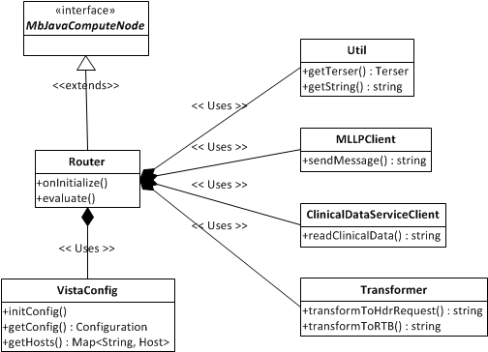

Figure 14: Class Methods

The Router.java class is the heart of the communication to the ESB that holds all the relevant logic for OneVA Pharmacy. This class extends IBMs MbJavaComputeNode. This compute node is initialized once to allow for any bootstrapping of the system and for each subsequent message that flows through the ESB by calling the evaluate () method.

When the compute node initializes, the VistaConfig class loads all the VistA hosts within the network for the given tier. An environment variable called ONEVA_TIER needs to be declared and set with a tier-specific value like “dev”, “test”, or “prod”. This tier will correspond to the set of VistA hosts to use by having a tier-specific name like, conf/dev-vista-host.csv. The file containing the VistA hosts information is in a Comma Separated Values, or CSV format, that can be used by any text editor or Excel. The format for the CSV file is the following:

SITE_ID, IP, HOSTNAME, PORT

An example would be: 0,127.0.0.1,localhost,44500

Once the initialization of the ESB finishes, messages then flow through the system. Each message is inspected by being parsed and accessed through a Terser. A Terser allows for easy access to an HL7 message contents through a short-hand notation. The destination of the message is determined by the site ID which corresponds to the SITE_ID in the CSV file. The VistA host lookup key must match in order to send the message.

Once the destination is known, the HL7 message is transformed via Transformer.transformToHdrRequest() and is sent as a parameter to the HDR/CDS web service endpoint via ClinicalDataServiceClient.readClinicalData(). The response from the HDR/CDS is transformed back into an HL7 message via Transformer.transformToRTB(). This transformed HL7 message is sent as a response to the calling VistA.

##### Class Properties

Not Applicable.

##### Uses Clause

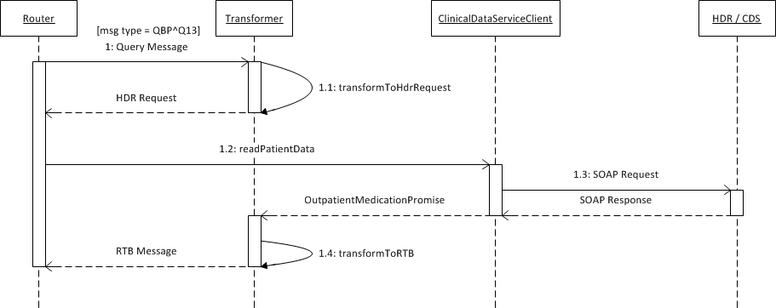

Figure 15: Uses Clause

The Use Case to query the HDR/CDS from the class level is as follows:

* [step 1] A message with the type of QBP^Q13 comes to the Router Java Compute Node
* [step 1.1] It is then transformed into an HDR/CDS request
* [step 1.2] The Router then calls the ClinicalDataServiceClient to query the HDR/CDS
* [step 1.3] ClinicalDataServiceClient does the actual work of querying the HDR/CDS
* [step 1.4] The response from the HDR/CDS is then transformed into an RTB response to be sent to the calling VistA

##### Forms

Not applicable.

##### Functions

Not applicable.

##### Dialog

Not applicable.

##### Help Frame

Not applicable.

##### HL7 Application Parameter

The MUMPS Patient Prescription Processing [PSO LM BACKDOOR ORDERS] menu option will be modified. The modifications include making a HL7 requests to the Prescription Manager Server for viewing and filling remote prescriptions.

### HL7 Protocols

An HL7 protocol event and subscriber will be configured in VistA to handle sending HL7 requests to the Prescription Manager Server. Protocols will be set up to handle all messages. The following is an example configuration of a protocol to handle QBP-Q13 Events:

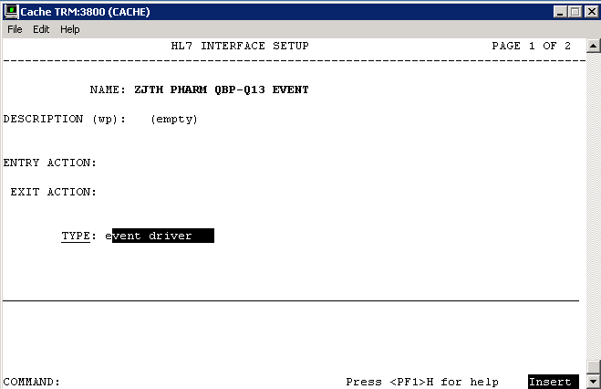

Figure 16: Example of Configuration of a Protocol to handle QBP-Q13 Events

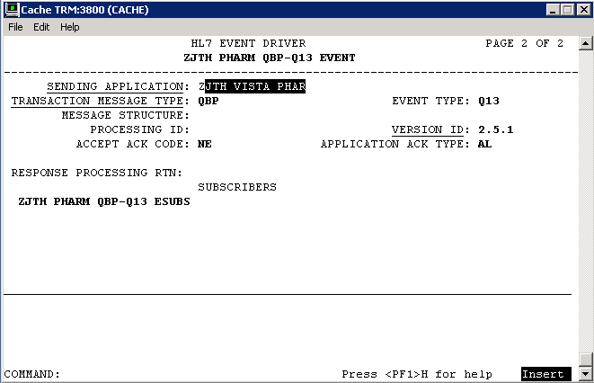

Figure 17: Example of Configuration of a Protocol to handle QBP-Q13 Events

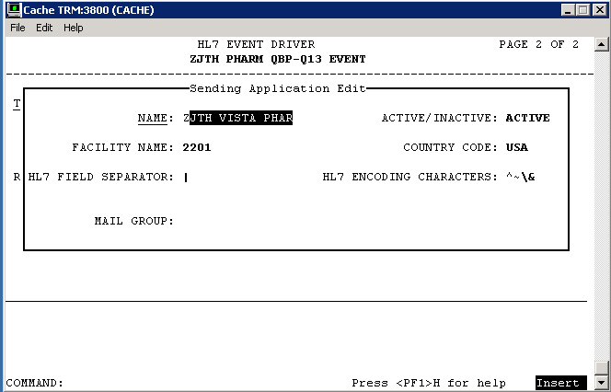

Figure 18: Example of Configuration of a Protocol to handle QBP-Q13 Events

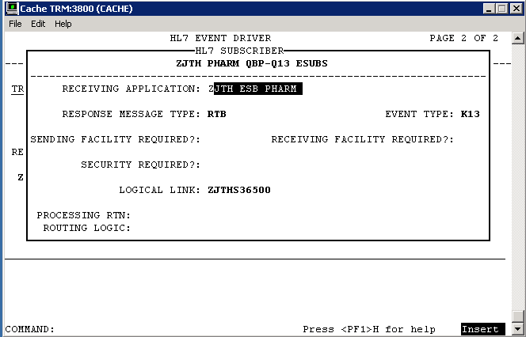

Figure 19: Example of Configuration of a Protocol to handle QBP-Q13 Events

### HL7 Sender and Receiver Applications

Sender and Receiver HL7 applications will be configured in VistA to fill MSH-3, 4, 5 and 6 fields. The Sending Application Facility Name is used to convey the site number of the VistA. The following is an example configuration of applications used in the protocols above:

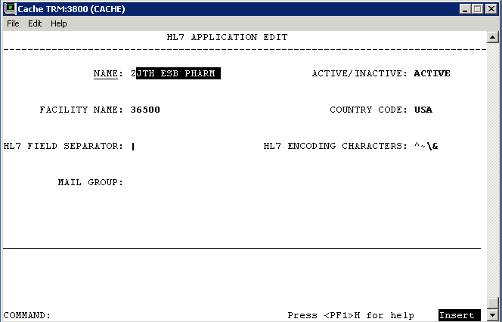

Figure 20: Receiving HL7 Application Configuration

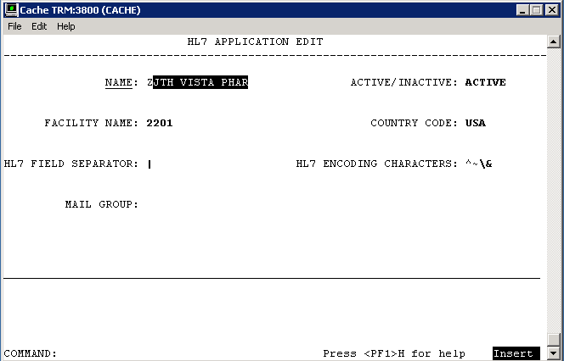

Figure 21: Sending HL7 Application Configuration

### Sender and Receiver Logical Links

A client logical link will be configured in VistA with the IP and Port of the EMI. Additionally, a server or listening logical link will be added. HL7 messaging will be used to exchange requests between the initiating VistA and the EMI. The following is an example configuration of logical links used in the applications above:

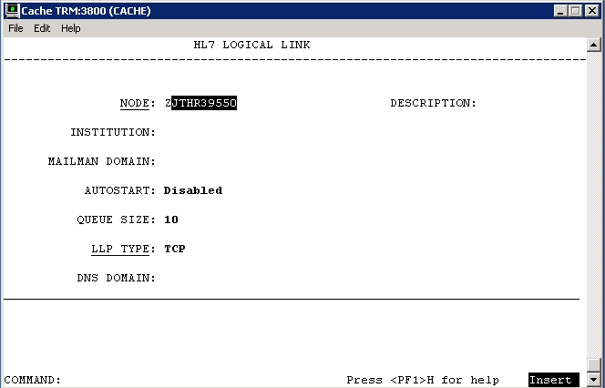

Figure 22: Example of Configuration of Logical Links

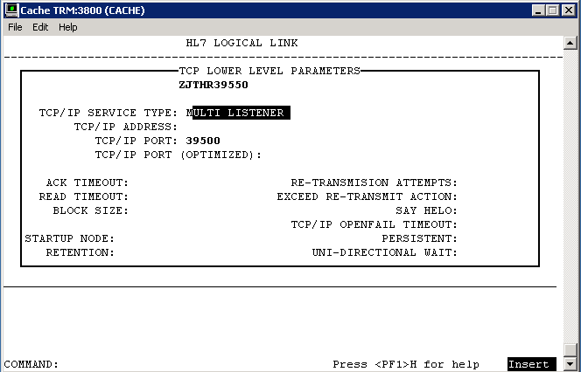

Figure 23: Example of Configuration of Logical Links

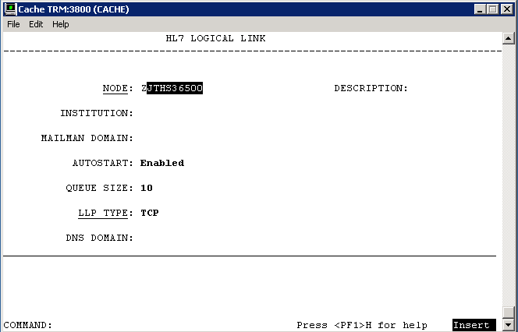

Figure 24: Example of Configuration of Logical Links

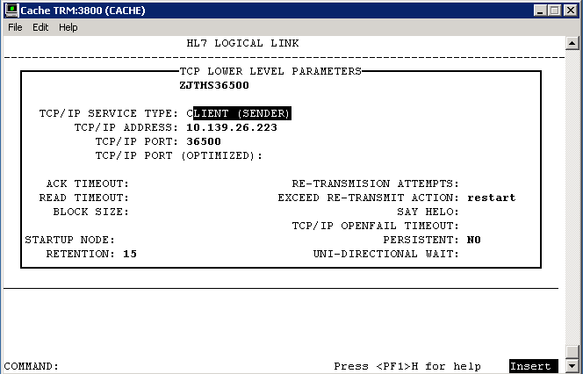

Figure 25: Example of Configuration of Logical Links

##### HL7 Logical Link

Table 56: HL7 Logical Link

| HL7 Logical Link | Description |
| --- | --- |
| **HL7 Logical Link Parameter Name** | **PSOR39550** - NAME CHANGE REQUIRED** |

|  |  |  |  |  |
| --- | --- | --- | --- | --- |
| **Enhancement Category** | **New** | **Modify** | **Delete** | **No Change** |

| Enhancement Category | Current | Modified |
| --- | --- | --- |
| **Node** | **N/A** | **ALL??** |
| **Institution** | **N/A** | **N/A** |
| **Domain** | **N/A** | **N/A** |
| **Autostart** | **N/A** | **Disabled** |
| **Queue Size** | **N/A** | **10** |
| **LLP Type** | **N/A** | **TCP** |

| HL7 Logical Link | Description |
| --- | --- |
| **HL7 Logical Link Parameter Name** | **PSOS36500** - NAME CHANGE REQUIRED** |

|  |  |  |  |  |
| --- | --- | --- | --- | --- |
| **Enhancement Category** | **New** | **Modify** | **Delete** | **No Change** |

| Enhancement Category | Current | Modified |
| --- | --- | --- |
| **Node** | **N/A** | **ALL??** |
| **Institution** | **N/A** | **N/A** |
| **Domain** | **N/A** | **N/A** |
| **Autostart** | **N/A** | **Enabled** |
| **Queue Size** | **N/A** | **10** |
| **LLP Type** | **N/A** | **TCP** |

##### COTS Interface

Not applicable.

## Network Detailed Design

The Network Design is a VA implementation and not being changed by the software being implemented within OneVA Pharmacy.

## Security and Privacy

### Security

#### Secure Sockets Layer (SSL)

The OneVA Pharmacy architecture does not use SSL to transport HL7 from VistA to/from the eMI ESB. The eMI ESB uses the HAPI (HL7 application programming interface; pronounced "happy") open-source, object-oriented HL7 2.x parser for Java which is capable of sending and receiving HL7 over SSL. The use of SSL is achievable with minor modifications to the eMI ESB. The scope and complexity of the changes required to VistA to support HL7 over SSL are unknown.

#### Authentication and Authorization

Authentication and Authorization for the OneVA Pharmacy have not yet been identified.

#### Remote Prescription Locking

Before any action is taken on a remote prescription, the prescription is locked. The lock only remains long enough for the routines to file the data, which is generally only a few milliseconds. This prevents a ‘remote’ refill or partial fill from occurring in the event that a user at the originating site is taking action on the same patient’s prescription.

### Privacy

Not applicable.

## Service Oriented Architecture / ESS Detailed Design

Services provided includes:

* Provides: Transport of HL7 messages to target VistA
* Provides: Proxy call to the HDR for a patient’s active prescriptions.
* Consumes: HDR query service

<http://www.techstrategies.oit.va.gov/docs/designpatterns/2.5%20Enterprise%20SOA%20Design%20Pattern%20%2810-20-2015%29.pdf>

### Service Description for <Consumed Service Name>

Not Applicable. No development of new service.

### Service Design for <Provided Service Name>

Not Applicable. No development of new service.

# External System Interface Design

## Interface Architecture

## Interface Detailed Design

HL7 v2.5.1 messaging is used to communicate between VistA and the eMI ESB. The following codes are provided for reference.

## Acknowledgement Codes

Table 8: Acknowledgement Codes

| Code | Status | Description |
| --- | --- | --- |
| AA | Application Accept | Requested action or operation was successfully performed |
| AR | Application Reject | Requested action or operation failed due to service errors |
| AE | Application Error | Requested action or operation failed due to HL7 message or semantic errors |

## Order Control Codes

Table 9: Order Control Codes

| Code | Status |
| --- | --- |
| RF | Refill order request |
| PF | Partial fill order request* |
| AF | Order refill authorization request approved |
| DF | Order refill authorization request denied |
| FU | Order refilled unsolicited at patient’s request |
| OF | Order refilled as requested by placer system |

*PF is not an HL7 standard code

## Remote Prescription Query Transaction

The remote prescription query request is a QBP^Q13 message type and the response is a KTB^K13 message type. The “Chapter” reference below refers to the HL7 Standard Version 2.5.1 documentation.

### Remote Prescription Query Request

The QBP^Q13 request is defined in Table 4. The implementation will ignore RDF and DSC segments and additionally, any segment not shown below is ignored.

Table 10: Remote Prescription Query Request

| QBP^Q13 | QBP Message | Chapter |
| --- | --- | --- |
| MSH | Message Header Segment | 2.15.9 |
| QPD | Query Parameter Definition | 5.5.4 |
| PID | Patient Identification | 3.4.2 |
| [RDF] | Table Row Definition Segment | 5.5.6.6 |
| RCP | Response Control Parameter | 5.5.6 |
| [DSC] | Continuation Pointer | 2.15.4 |

Table 11: QPD Field Description and Commentary

| Field Seq | Field Name | HL7 Data Type | Description |
| --- | --- | --- | --- |
| 1 | Message Query Name | CE | Must be Q13^Active Prescriptions^HL70471 |
| 2 | Query Tag | ST | Unique to each query message instance |

Table 12: PID Field Description and Commentary

| Field Seq | Field Name | HL7 Data Type | Description |
| --- | --- | --- | --- |
| 1 |  |  | Ignored |
| 2 |  |  | Ignored |
| 3 | MRN | CX | One or more patient identifiers may be sent. Each site provided and configured will be queried for prescriptions. |
| n |  |  | Ignored |

RCP Field Description and Commentary

Table 13: RCP Field Description and Commentary

| Field Seq | Field Name | HL7 Data Type | Description |
| --- | --- | --- | --- |
| 1 | Query Priority | ST | Must be “I” for Immediate |
| n |  |  | Ignored |

### Sample QBP^Q13 Request

**MSH**|^~\&|PSO VISTA PHARM|2101|PSO MIRTH PHARM|36500|20140102125951-0500||QBP^Q13|301|T|2.5.1|||NE|AL|USA

**QPD**|Q13^Active Prescriptions^HL70471|512123456

**PID**|||1666000286V397907^^^USVHA^NI^200M~100232^^^USVHA^PI^500~100445^^^USVHA^PI^612~100232^^^USVHA^PI^2204~100232^^^USVHA^PI^2202

RCP|I

### Remote Prescription Query Response

The KTB^K13 response is defined as follows.

Table 14: Remote Prescription Query Response

| KTB^Q13 | QBP Message | Chapter |
| --- | --- | --- |
| MSH | Message Header Segment | 2.15.9 |
| MSA | Message Acknowledgement | 2.15.8 |
| [ERR] | Error | 2.15.5 |
| QAK | Query Acknowledgement | 5.5.2 |
| ZAK | Z-Segment | Defined below |
| QPD | Query Definition Segment | 5.5.4 |
| RDF | Table Row Definition Segment | 5.5.6.6 |
| [{RDT}] | Table Row Data Segment | 5.5.6 |

An ERR segment will be sent when MSA.1 acknowledgement code is AR or AE.

Table 15: RCP Field Description and Commentary

| Field Seq | Field Name | HL7 Data Type | Description |
| --- | --- | --- | --- |
| 1 | Site Number | ST | VistA site number |
| 2 | Count returned | NM | Count of rows returned from VistA site |
| 3 | Success indicator | NM | 1 – success  0 – unknown error  -1 – connection failure  -2 – response timeout |

The RDF segment and data in the RDT segment contains the following fields:

* Site Number
* Rx Number
* Drug Name
* Quantity
* Refills
* Days Supply
* Expiration Date
* Issue Date
* Stop Date
* Last Fill
* Sig
* Detail

### Sample KTB^K13 Response

**MSH**|^~\&|PSO MIRTH PHARM|36500|PSO VISTA PHARM|2101|20140109155138.281-0500||ACK^Q13^ACK|19|T|2.5.1

**MSA**|AA|50022643

**QAK**|512123456|OK|Q13^Active Prescriptions^HL70471|2

**ZAK**|2302|3|1|Success

**ZAK**|2303|0|-1|Connection timeout.

**RDF**|12|Site Number~Rx Number~Drug Name~Quantity~Refills~Days Supply~Expiration Date~Issue Date~Stop Date~Last Fill Date~Sig~Detail

**RDT**|2302|501109|NAPROXEN 250MG TAB|60|11|30|20150517.000000|20140516.000000|20150517.000000|20140516.000000|TAKE ONE TABLET BY MOUTH TWICE A DAY|NAPROXEN 250MG TAB Qty: 60 for 30 days

**RDT**|2302|501110|RANITIDINE HCL 25MG EFFER TAB|60|6|30|20150517.000000|20140516.000000|20150517.000000|20140516.000000|DISSOLVE 1 MOUTH TWICE A DAY|RANITIDINE HCL 25MG EFFER TAB Qty: 60 for 30 days

**RDT**|2302|501123|ACETAMINOPHEN 325MG TAB|240|5|30|20150726.000000|20140725.000000|20150726.000000|20140814.000000|TAKE TWO TABLETS BY MOUTH EVERY 6 HOURS AS NEEDED |ACETAMINOPHEN 325MG TAB Qty: 240 for 30 days

## Remote Prescription Dispense Transaction

The remote prescription refill dispense request is a RDS^O13 message type and the response is a RRD^O14 message type. This message is used to convey that the requesting system wishes to lock the remote order. The “Chapter” reference below refers to the HL7 Standard Version 2.5.1 documentation.

### Remote Description Dispense Request

The RDS^O13 request is defined in the following table and any segment not shown is ignored.

Table 16: Remote Description Dispense Request

| RDS^O13 | RDS Message | Chapter |
| --- | --- | --- |
| MSH | Message Header Segment | 2.15.9 |
| PID | Patient Identification | 3.4.2 |
| ORC | Common Order | 4.5.1 |
| RXO | Pharmacy/Treatment Prescription Order | 4.14.1 |

Table 17: PID Field Description and Commentary

| Field Seq | Field Name | HL7 Data Type | Description |
| --- | --- | --- | --- |
| 1 |  |  | Ignored |
| 2 |  |  | Ignored |
| 3 | MRN | CX | One or more patient identifiers may be sent. Each site provided and configured will be queried for prescriptions. |
| n |  |  | Ignored |

Table 18: ORC Field Description and Commentary

| Field Seq | Field Name | HL7 Data Type | Description |
| --- | --- | --- | --- |
| 1 | Order Control | ID | **Error! Reference source not found.** **Error! Reference source not found.** |
| 2 | Placer Order Number | EI | The originating order prescription number |
| 3 |  |  | Ignored |
| 4 |  |  | Ignored |
| 5 |  |  | Ignored |
| 6 |  |  | Ignored |
| 7 |  |  | Ignored |
| 8 |  |  | Ignored |
| 9 | Date/Time Transaction | TS | Date/Time of request |
| 10 | Entered By | XCN | Provides pharmacist identifier and name |
| 11 |  |  | Ignored |
| 12 |  |  | Ignored |
| 13 | Enterer’s Location | PL | Provides pharmacist’s site number |
| 14 | Call Back Phone Number | XTN | Provides pharmacist’s callback phone number |

Table 19: RXO Field Description and Commentary

| Field Seq | Field Name | HL7 Data Type | Description |
| --- | --- | --- | --- |
| 1 |  |  | Ignored |
| 2 |  |  | Ignored |
| 3 |  |  | Ignored |
| 4 |  |  | Ignored |
| 5 |  |  | Ignored |
| 6 |  |  | Ignored |
| 7 |  |  | Ignored |
| 8 | Deliver-To Location | LA1 | Provides (W)indow, (M)ail and requesting site number |

Sample RDS^O13 Refill Request

**MSH**|^~\&|PSO VISTA PHARM|2201|PSO ESB PHARM|36500|20140415110833-0500||RDS^O13|50024242|T|2.5.1|||NE|AL|USA

**PID**|||1666000286V397907^^^USVHA^NI^200M~100232^^^USVHA^PI^2202

**ORC**|RF|500974^2202|||||||20140415|1^PROGRAMMER^ONE|||^^^500|6655544

**RXO**||||||||W^^^2201

Sample RDS^O13 Partial Fill Request

**MSH**|^~\&|PSO VISTA PHARM|2201|PSO ESB PHARM|36500|20140716081903-0500||RDS^O13|50030627|T|2.5.1|||NE|AL|USA

**PID**|||1111000440V046182^^^USVHA^NI^200M~101016^^^USVHA^PI^2202

**ORC**|PF|501145^2202|||||||20140710|10000000225^TERRELL^GAIL|||^^^500|502-233-2355

**RXO**|1|10||||||W^^^500|||10

**NTE**|1|L|test

### Remote Description Dispense Response

The RRD^O14 response is defined as follows.

Table 20: Remote Description Dispense Response

| RRD^O14 | RRD Message | Chapter |
| --- | --- | --- |
| MSH | Message Header Segment | 2.15.9 |
| MSA | Message Acknowledgement | 2.15.8 |
| [ERR] | Error | 2.15.5 |
| ORC | Common Order | 4.5.1 |
| RXD | Pharmacy/Treatment Dispense Segment | 4.14.1 |

An ERR segment will be sent when MSA.1 acknowledgement code is AR or AE.

Table 21: RXD Field Description and Commentary

| Field Seq | Field Name | HL7 Data Type | Description |
| --- | --- | --- | --- |
| 1 |  |  | Ignored |
| 2 | Dispense/Give Code | CE | National Drug Code (NDC) |
| 3 | Date/Time Dispensed | TS |  |
| 4 | Actual Dispense Units | CE |  |
| 5 |  |  | Ignored |
| 6 |  |  | Ignored |
| 7 | Prescription Number | ST | Format: PSOIEN::REFIEN |
| 8 | Number of Refills Remaining | NM |  |
| 9 |  |  | Ignored |
| 10 | Dispensing Provider | XCN |  |
| 11 |  |  |  |
| 12 | Total Daily Dose | CQ | Days Supply |

Sample RRD^O14 Refill Response

MSH|^~\&|PSO ESB PHARM|36500|PSO VISTA PHARM|2302|20140723091250.151-0400||ACK^O13^ACK|12173|T|2.5.1

MSA|AR|50024459

PID|||1111000449V272697^^^USVHA^NI^200M~101044^^^USVHA^PI^2303

ORC|UF|501109^2303|||||||20140723|10000000225^TERRELL^GAIL|||^^^500|490-444-5555

Sample RRD^O14 Partial Fill Response

**MSH**|^~\&|PSO ESB PHARM|36500|PSO VISTA PHARM|2201|20140716081939.298-0400||ACK^O13^ACK|10412|T|2.5.1

**MSA**|AA|50030627

**NTE**|1||Partial complete for RX #501145.

**PID**|||1111000440V046182^^^USVHA^NI^200M~101016^^^USVHA^PI^2202

**ORC**|OF|501145^2202|||||||20140710|10000000225^TERRELL^GAIL|||^^^500|502-233-2355

**RXD**|1|^NAPROXEN 125MG/5ML SUSP^NDC|20140710000000-0400|10|||404366::1|||^RADIOLOGIST^ONE^^^^^^^^^^^^^2&VEHU SITE^^^20140717162300-0400||10

# Human-Machine Interface

The OneVA Pharmacy Implementation project will utilize existing Vista functionality to the fullest extent possible.

## Interface Design Rules

Not Applicable.

## Inputs

Not Applicable

## Outputs

Describe the system output design relative to the user. System outputs include reports, data display screens, query results, etc.

Identify the following, if appropriate:

* Access restrictions or security considerations
* Description of the purpose of the output
* Report requirements, including frequency of periodic reports
* Screen contents. (Provide a graphic representation of each layout. Define all data elements associated with the layout).

## Navigation Hierarchy



Figure 26: Navigational Hierarchy

### Prescription Display

PSO LM BACKDOOR ORDERS will be modified to display remote Rx’s in the same screen where the local Rx’s are displayed for a patient. The remote prescriptions will occur after any local Rx’s and will have a section header ‘-----SITE NAME (SITE NUMBER)----‘delineation. Leveraging existing functionality means less training, and more immediate familiarity with the process.

Once the user selects to ‘Refill’ or ‘Partially Refill’, a prompt will display to enter the required information for sending a request to the ‘originating’ system, so that the refill or partial fill may be completed and the Rx data updated.

The ‘Select Order’ function within PSO LM BACKDOOR ORDERS will be modified to differentiate between the local and remote orders and pull from the remote order ^XTMP array when needed.

Once the user has selected the order, a new option will be available to either ‘refill remote order’ or ‘partial refill remote order’. The updates to the data will occur on the system of origin. Additional fields will be added to the Prescription file (#52) but have yet to be fully determined. The fields will include, remote pharmacist name, remote pharmacist phone number, and remote filling site.

A new local file will be added to hold the information about the remote prescription that has been filled. This file will contain information about the site, Rx number, pharmacist who filled the Rx, and the date the prescription was filled in the ‘local’ system. This file will be used for reporting and tracking purposes.

Additional options may be made available for reprinting of labels.

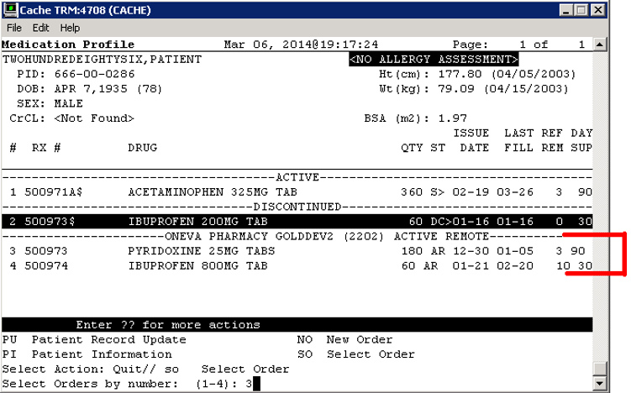

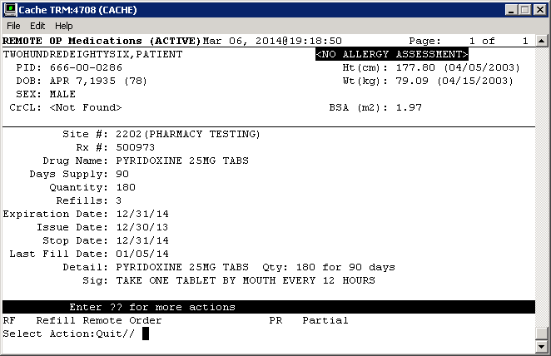

# Attachment A – Approval Signatures

This section is used to document the approval of the OneVA Pharmacy Implementation System Design Document during the Formal Review. The review should be ideally conducted face to face where signatures can be obtained ‘live’ during the review however the following forms of approval are acceptable:

1. Physical signatures obtained face to face or via fax

2. Digital signatures tied cryptographically to the signer

3. /es/ in the signature block provided that a separate digitally signed e-mail indicating the signer’s approval is provided and kept with the document

The following members of the governing Integrated Project Team (IPT) are required to sign. Please annotate signature blocks accordingly.

REVIEW DATE:

SCRIBE:

Signed:

______________________________________________________________________________

Joshua Patterson Date

Integrated Project Team (IPT) Chair

______________________________________________________________________________

Michael Valentino Date

Business Sponsor

______________________________________________________________________________

Cecelia Wray Date

Project Manager

1. Additional Information
   1. Identification of Technology and Standards

Reference materials includes the following:

* IEEE 2016-2009, Systems Design / Software Design Descriptions – <http://standards.ieee.org/findstds/standard/1016-2009.html>
* HL7 Messaging Standard v2.5.1 - <http://www.hl7.org/implement/standards/product_brief.cfm?product_id=144>
* VA118-13-R-0445, B.3 Performance Work Statement issued 2013-07-26
* Medical Domain Web Services (MDWS) documentation - <http://va.gov/vdl/application.asp?appid=192>
* HL7 (VistA Messaging) documentation - <http://va.gov/vdl/application.asp?appid=8>
* My HealtheVet documentation - <http://va.gov/vdl/application.asp?appid=153>
  1. Constraining Policies, Directives and Procedures

Not applicable.

* 1. Requirements Traceability Matrix

The Requirements Traceability Matrix can be can be found on GitHub under the VHAINNOVATIONS / One-VA-Pharmacy Repository.

* 1. Packaging and Installation

Outline any special considerations for software packaging and installation.

* 1. Design Metrics

Not applicable.